## Visoka skola strukovnih studija za informacione i komunikacione tehnologije

**HomeTheater**

<http://hometheater.epizy.com>

Smer: Internet tehnologije

Modul: Web programiranje

Predmet: Web programiranje PHP 1

Andrej Zarkovski 22/18

**Sadržaj**

1.Uvod................................................................................................................................... 4

**Korišćeni programski jezici** 4

**Opis funkcionalnosti** 4

2.Organizacija 6

**Organizaciona šema** 6

**Mapa sajta** 8

**Opis stranica sajta** 10

index.php (neautorizovani korisnici) 10

index.php (autorizovani korisnici) 17

movies.php 20

tvshows.php 22

contact.php 23

about.php 24

bookmarks.php 25

manage_content_library.php 26

login.php 29

register.php 30

403.php 31

3. Kodovi......................................... 32

PHP 32

index.php 32

movies.php 33

tvshows.php 34

contact.php 35

about.php 36

login.php 37

register.php 38

logout.php 39

403.php 40

Authorized user pages 41

bookmarks.php 41

manage_content_library.php 42

Views 43

head.php 43

header.php 44

footer.php 47

index_content.php 54

movies_content.php 67

tvshows_content.php 69

login_content.php 71

register_content.php 72

contact_content.php 74

about_content.php 75

403_content.php 77

bookmarks_content.php 78

manage_content_library_content.php 79

Logic 83

addContent.php 83

bookmarks_processor.php 88

business_processor.php 90

contact_processor.php 91

dbConnection.php 92

getAllCategories.php 93

getAllContentTypes.php 94

getAllResolutions.php 95

getContentInfo.php 96

getContentItems.php 98

getContentWithWallpapers.php 102

getCTRC.php 104

login_processor.php 105

menuFetcher.php 106

register_processor.php 107

removeContentItem.php 109

setUserBookmark.php 110

survey_processor.php 112

SurveyLib.php 113

updateContent.php 114

# Uvod

## **Korišćeni programski jezici**

Za izradu sajta korišćene su sledeće tehnologije:

* + - PHP (Xampp)
    - HTML 5
    - CSS 3/ SASS
    - Bootstrap
    - JavaScript
    - jQuery
    - jQuery plugin - nicescroll
    - Visual Studio Code
    - Photoshop
    - Mockplus

## **Opis funkcionalnosti**

Sajt poseduje sledeće funkcionalnosti:

* Dinamicko ucitavanje navigacionog menija, menija u futeru, i account panel menija
* Dinamicko ucitavanje naslovnica filmova i serija
* Slajder najnovijih filmova
* Anketa i pamcenje odgovora ankete
* Registracija/logovanje
* Pravljenje bookmark liste filmova i serija
* Admin panel – upis novih filmova/serija, izmena i brisanje
* Filtriranje filmova/serija po kategoriji, sortiranje istih, kao i pretraga po naslovu
* Kontakt forma za slanje mail-a administratoru, validacija unetih podataka na klijentskoj i serverskoj strani

# Organizacija

## **Organizaciona šema**

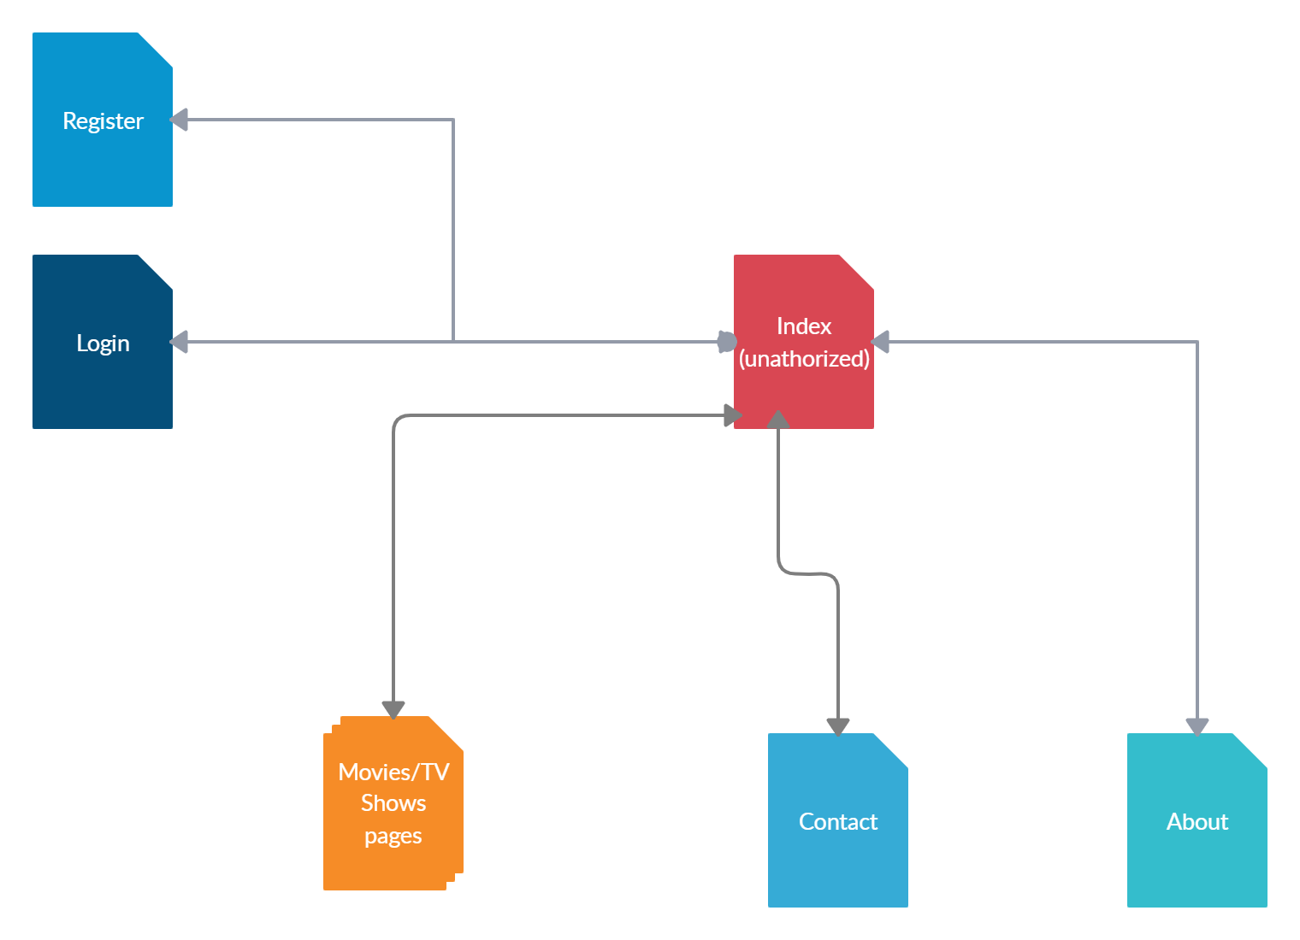

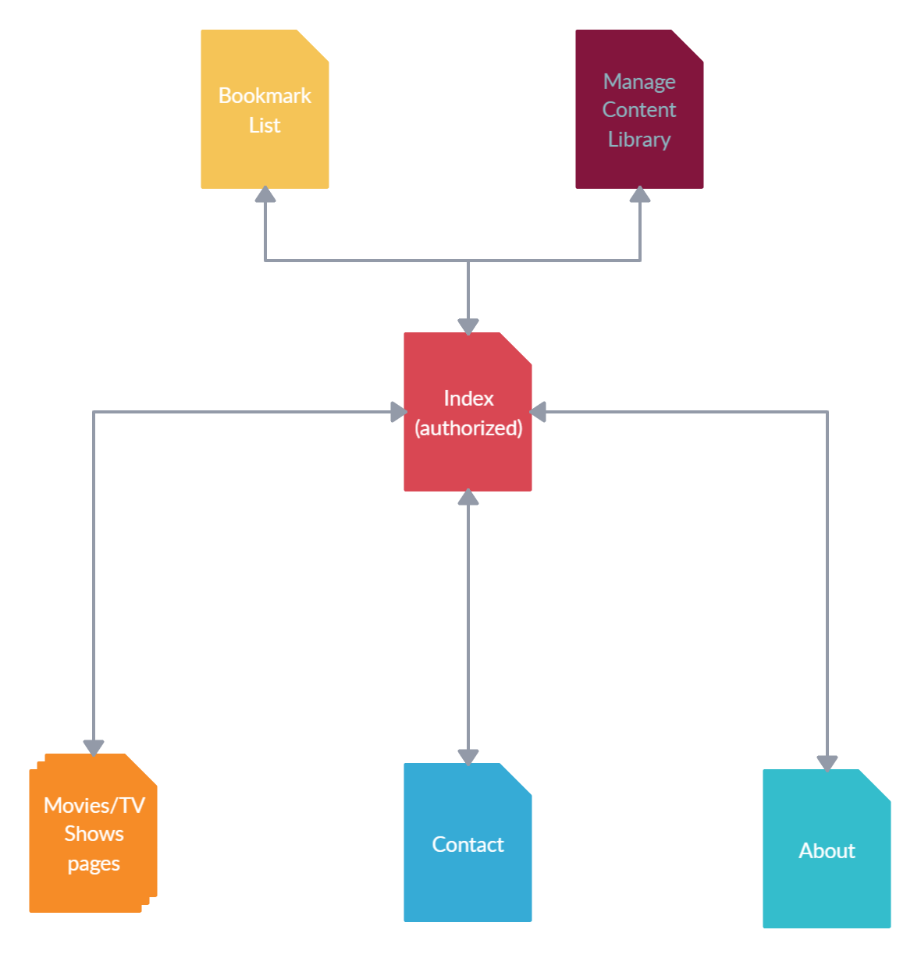

## **Mapa sajta**

<?xml version="1.0" encoding="UTF-8"?>

<urlset

      xmlns="http://www.sitemaps.org/schemas/sitemap/0.9"

      xmlns:xsi="http://www.w3.org/2001/XMLSchema-instance"

      xsi:schemaLocation="http://www.sitemaps.org/schemas/sitemap/0.9

            http://www.sitemaps.org/schemas/sitemap/0.9/sitemap.xsd">

<url>

  <loc>http://hometheater.epizy.com</loc>

  <lastmod>2020-03-18</lastmod>

  <priority>1.00</priority>

  <changefreq>daily</changefreq>

</url>

<url>

  <loc>http://hometheater.epizy.com/movies.php</loc>

  <lastmod>2020-03-18</lastmod>

  <priority>0.90</priority>

  <changefreq>daily</changefreq>

</url>

<url>

  <loc>http://hometheater.epizy.com/tvshows.php</loc>

  <lastmod>2020-03-18</lastmod>

  <priority>0.90</priority>

  <changefreq>daily</changefreq>

</url>

<url>

  <loc>http://hometheater.epizy.com/contact.php</loc>

  <lastmod>2019-02-18</lastmod>

  <priority>0.70</priority>

  <changefreq>monthly</changefreq>

</url>

<url>

  <loc>http://hometheater.epizy.com/about.php</loc>

  <lastmod>2019-03-18</lastmod>

  <priority>0.50</priority>

  <changefreq>yearly</changefreq>

</url>

<url>

  <loc>http://hometheater.epizy.com/login.php</loc>

  <lastmod>2020-02-18</lastmod>

  <priority>0.80</priority>

  <changefreq>monthly</changefreq>

</url>

<url>

  <loc>http://hometheater.epizy.com/register.php</loc>

  <lastmod>2020-02-18</lastmod>

  <priority>0.80</priority>

  <changefreq>monthly</changefreq>

</url>

<url>

  <loc>http://hometheater.epizy.com/auth/manage_content_library.php</loc>

  <lastmod>2019-03-18</lastmod>

  <priority>0.60</priority>

  <changefreq>yearly</changefreq>

</url>

<url>

  <loc>http://hometheater.epizy.com/auth/bookmarks.php</loc>

  <lastmod>2019-02-18</lastmod>

  <priority>0.50</priority>

  <changefreq>yearly</changefreq>

</url>

<url>

  <loc>http://hometheater.epizy.com/logout.php</loc>

  <lastmod>2019-02-18</lastmod>

  <priority>0.50</priority>

  <changefreq>yearly</changefreq>

</url>

</urlset>

## **Opis stranica sajta**

### index.php (neautorizovani korisnici)

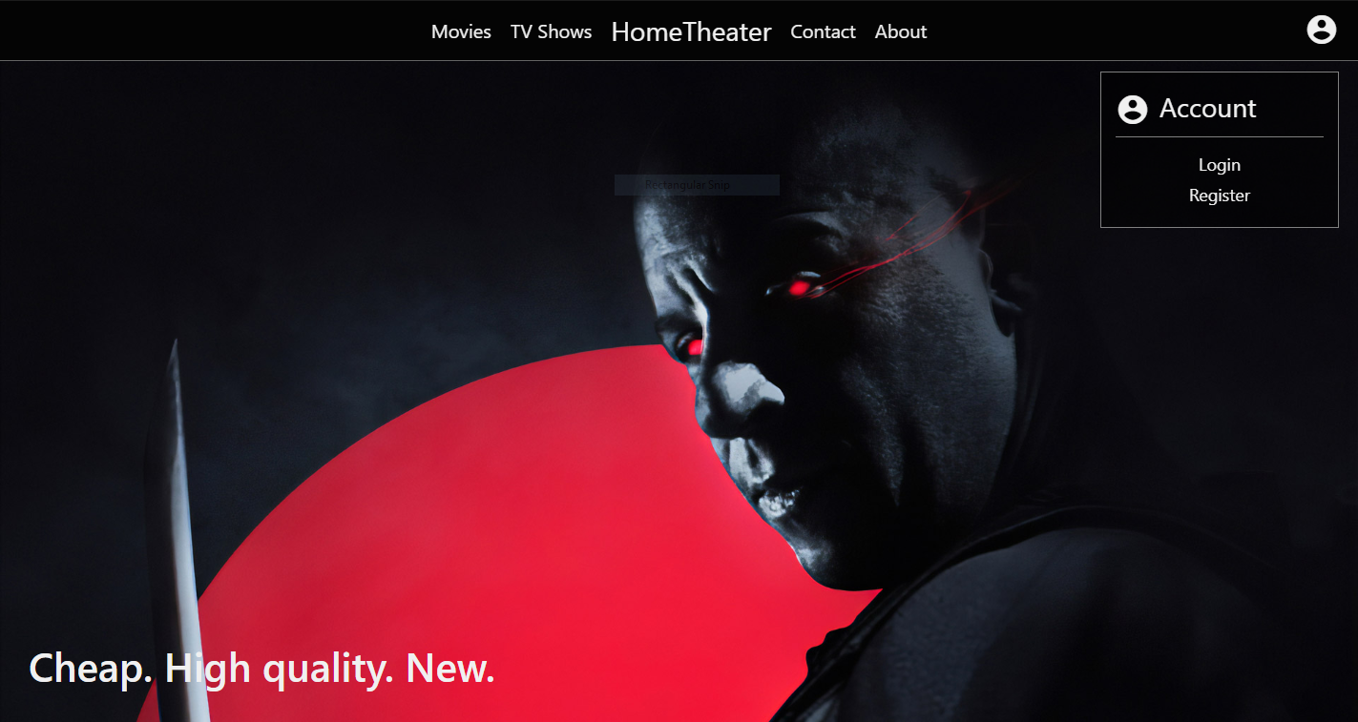

Na svakoj stranici se nalazi dinamicki ucitan navigacioni meni koji je fiksan, a u gornjem desnom uglu se nalazi dugme koje otvara dijalog sa linkovima ka login-u/registraciji. 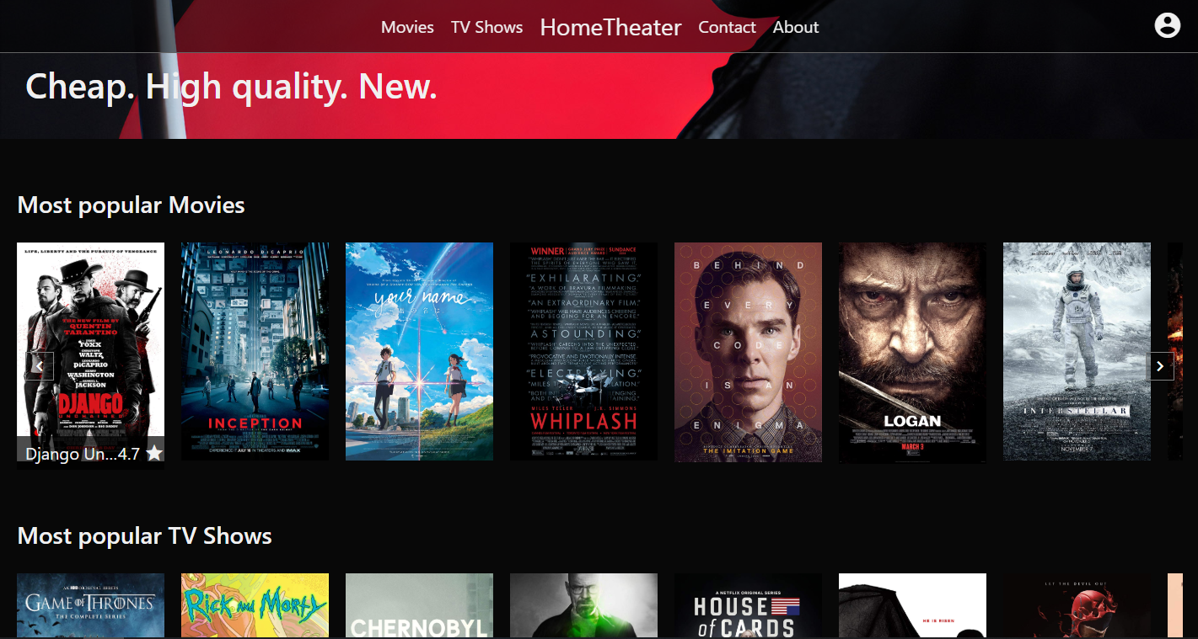

Potom imamo dve sekcije sa najpopularnijim filmovima i serijama. Sa leve i desne strane sekcije, nalaze se navigacioni dugmici koji skroluju sekciju u horizontalnom smeru.

Prelaskom misa preko stavke sekcije (filma/serije), prikazuje se ime tog filma, kao i prosecna ocena od svih korisnika koji su ocenili film.

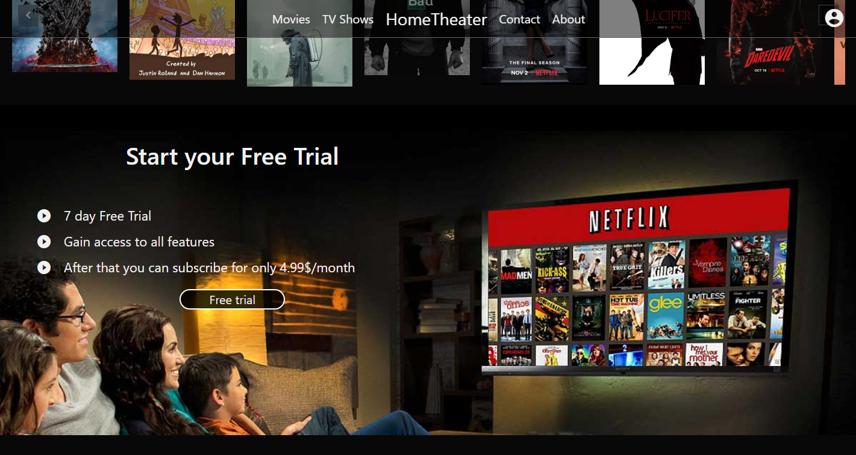

Staticka sekcija za besplatno testiranje sajta na 7 dana.

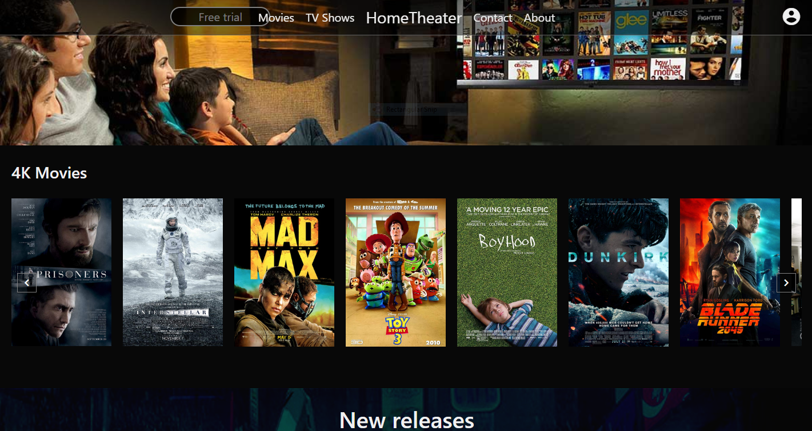

Nakon toga imamo sekciju sa listom filmova u 4K rezoluicji.

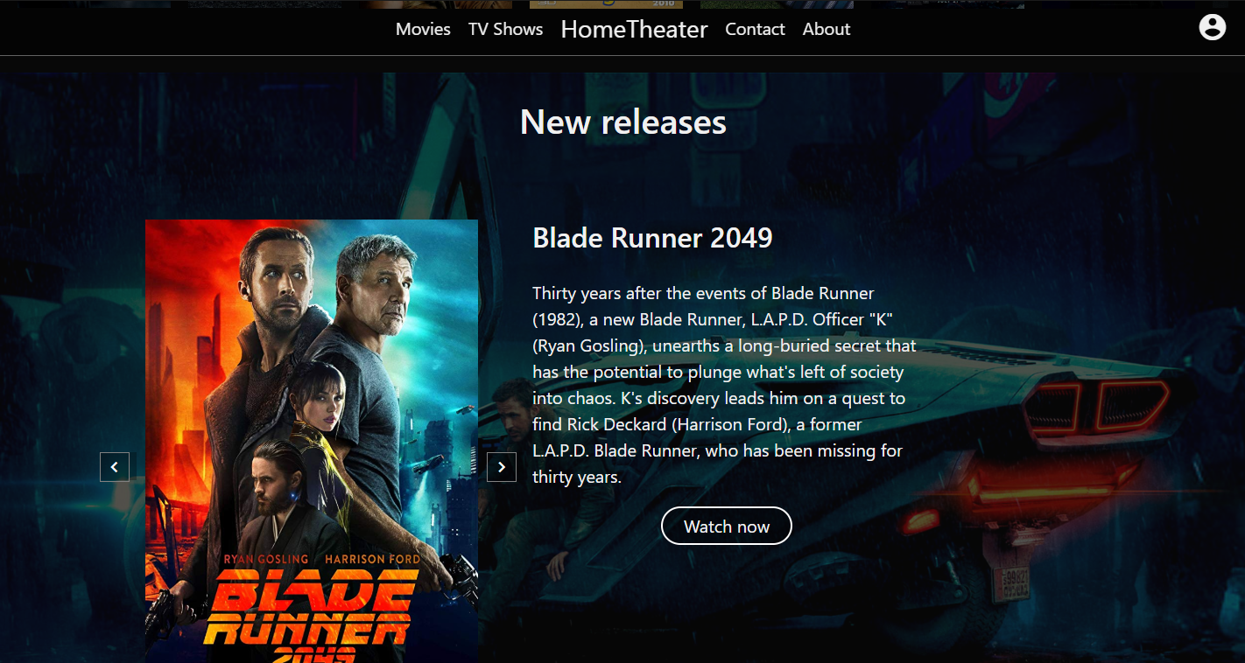

Posle sekcije sa 4k filmovima, nalazi se slajder sa najnovijim izdanjima filmova i serija.

Sa strane naslovnice nalaze se dugmici koji ucitavaju sledeci/prethodni film, odnosno seriju.

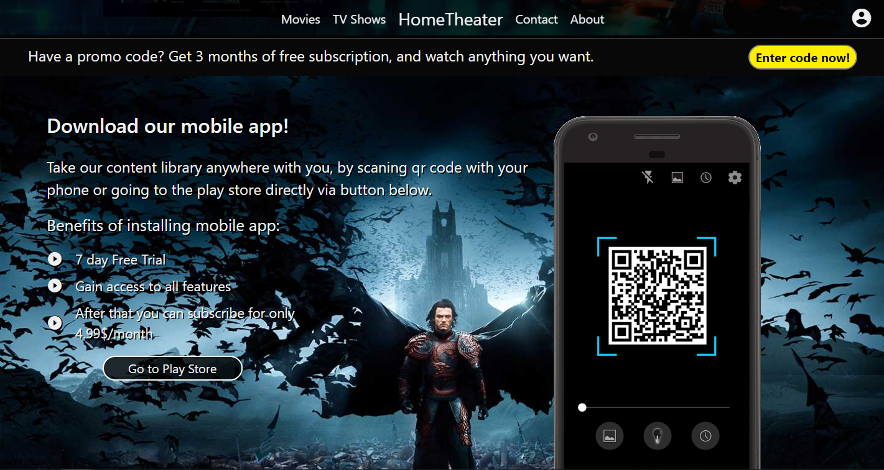

Dve staticke sekcije za unosenje promo koda za popust na pretplatu i za promovisanje mobilne aplikacije.

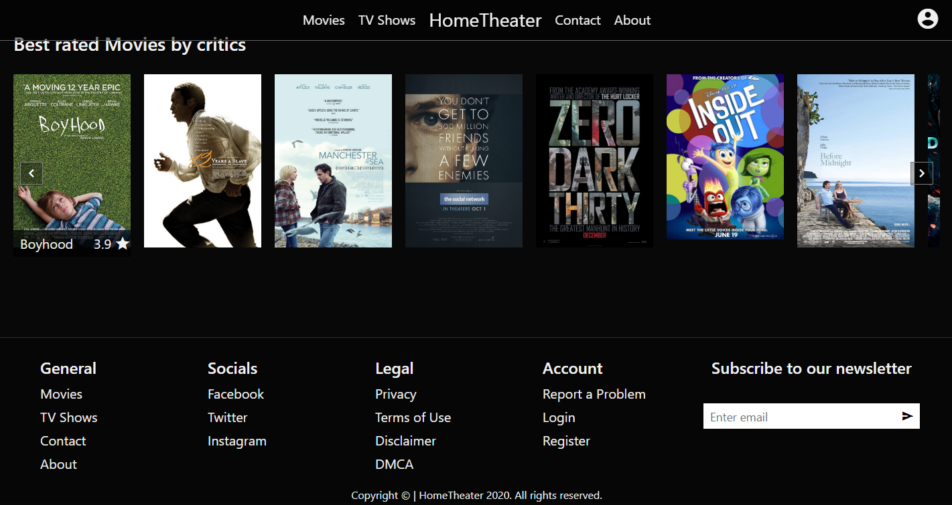

Odmah ispod nalazi se sekcija sa filmovima najbolje ocenjenim od strane kriticara kao i futer sa dinamciki ucitanim linkovima.

### index.php (autorizovani korisnici)

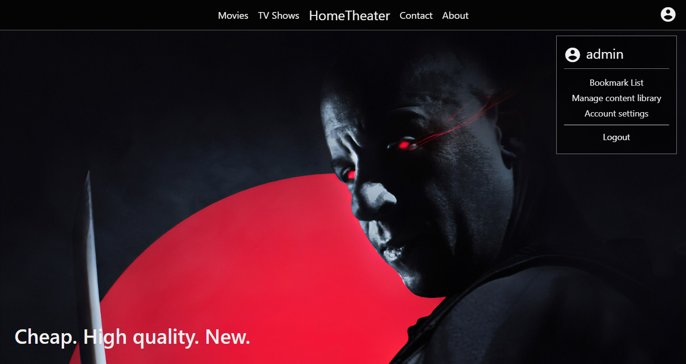

Dijalog za nalog kod autorizovanih korisnika ima linkove koji su prikazani na slici iznad, s tim sto samo admin nalozi imaju link »Manage content library«, dok ostali autorizovani korisnici nemaju.

P.S. Link »Account settings« je samo dekoracija/za popunu prostora menija.

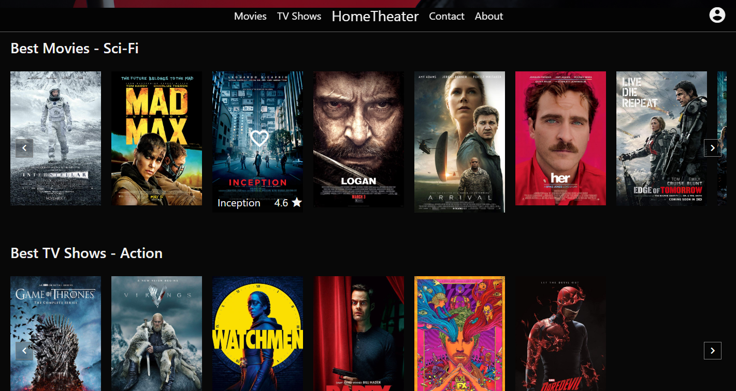

Na pocetnom delu stranice nalaze se dve sekcije sa filmovima i serijama sa nasumicno odabranim kategorijama.

Prelaskom misa preko bilo kojeg filma/serije pojavljuje se srce, cijim se klikom taj film/serija dodaje u boomark listu za ulogovanog korisnika.

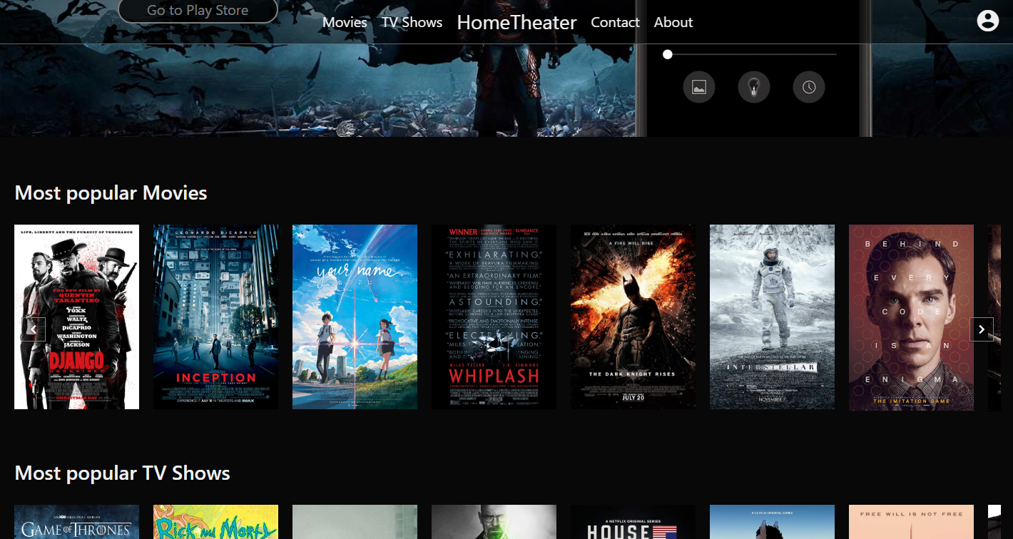

Sekcije »Most popular Movies« i »Most popular TV Shows« su ostale nepromenjene, i pomerene su na dno stranice, gde su pre bile pri vrhu kod neautorizovanih korisnika.

Sekcije »New releases«, »4K Movies«, sekcija za mobilnu aplikaciju, kao i futer ostali su nepromenjeni.

Sekcija za promo kod je sakrivena kod autorizovanih korisnika.

### movies.php

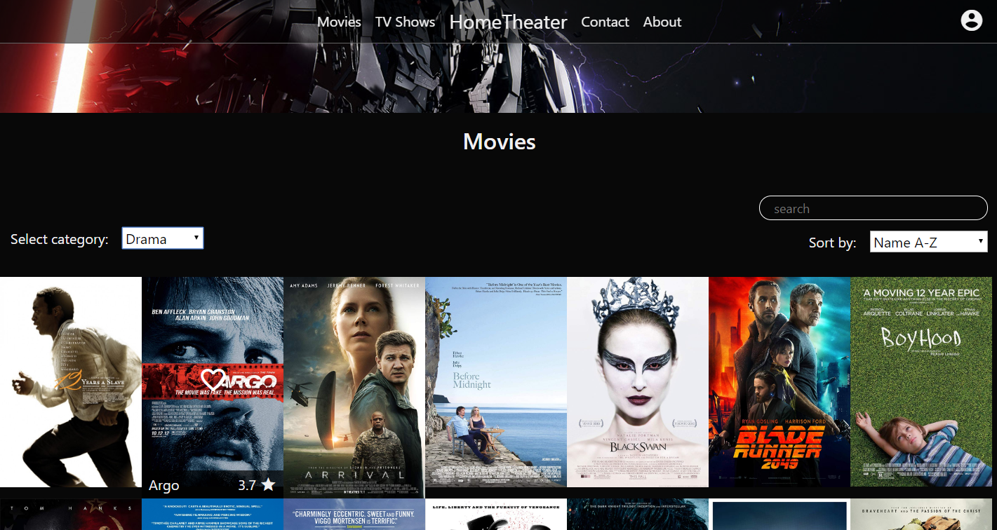

Stranica za prikaz svih filmova. Sadrzi filter za kategoriju filma, dropdown za sortiranje prikazanih filmova, kao i teksutalno polje sa pretrazivanje filmova po naslovu.

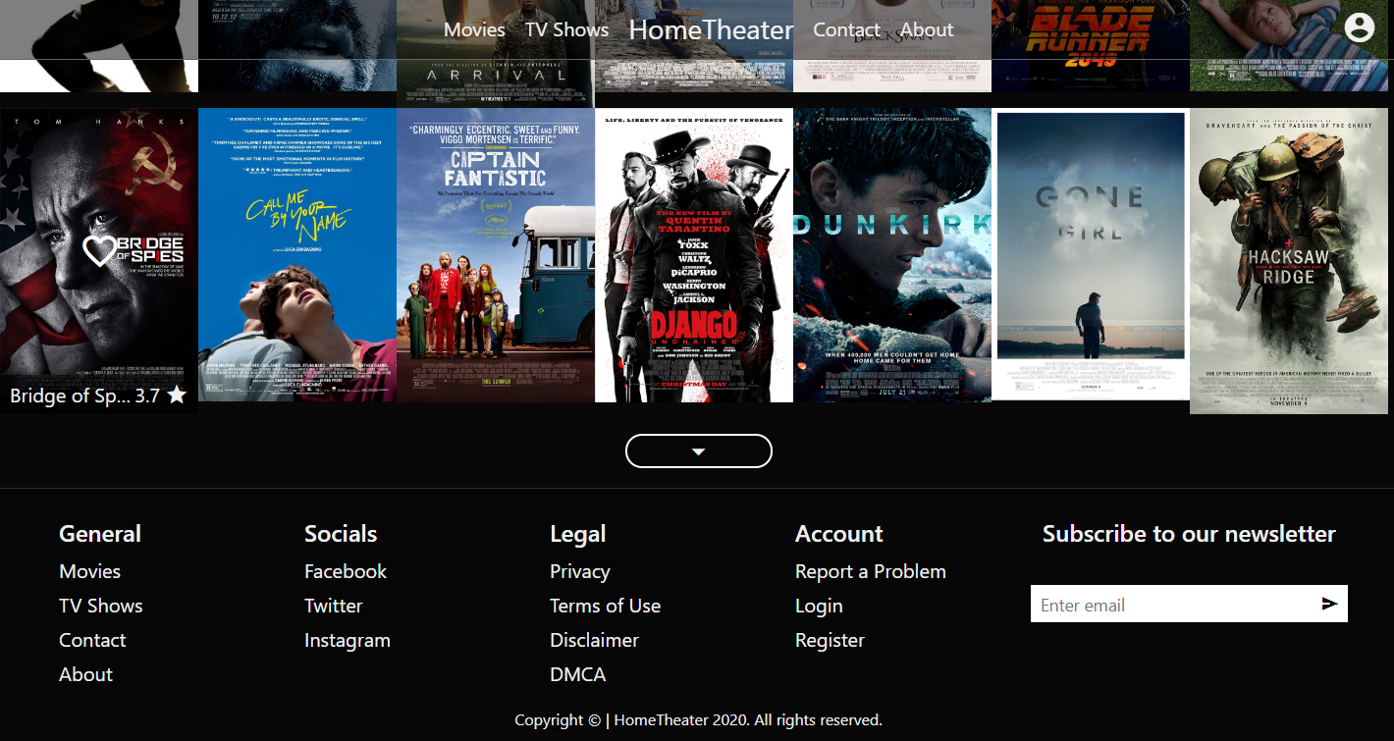

Pri dnu liste nalazi se dugme za ucitavanje jos filmova po izabranom filteru. Ukoliko nema dodatnih filmova za ucitavanje, dugme se sakriva.

### tvshows.php

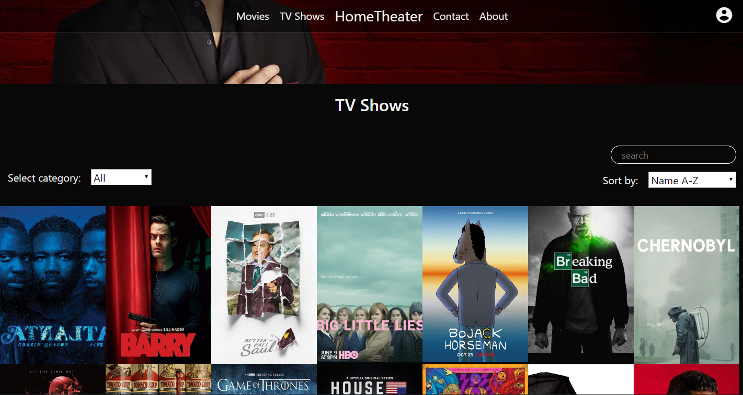

Stranica za prikaz svih serija je po funkcionalnosti identicna kao i stranica za prikaz filmova.

### contact.php

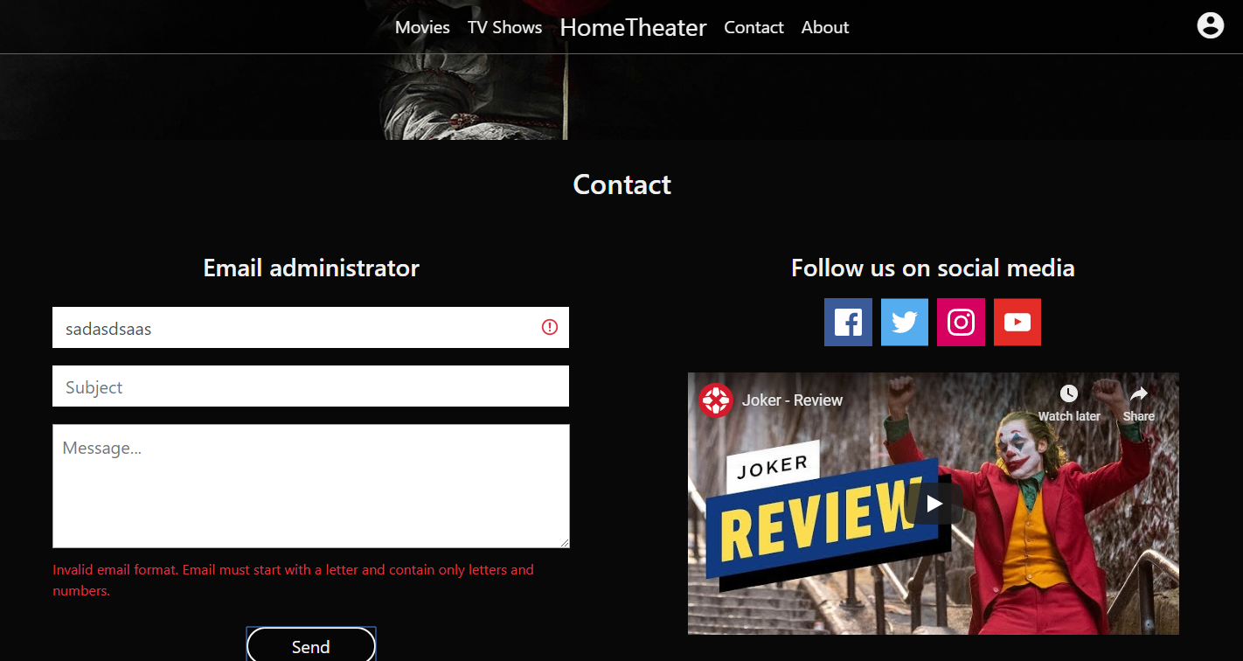

Na stranici za kontakt sa leve strane nalazi se forma za slanje mail-a administratoru. Unosom ispravnih podataka prikazuje se poruka da je mejl uspesno poslat. A pri neispravnom unosu, ispisuje se poruka crvenim slovima, kao na slici iznad, o tipu greske.

Sa desne strane nalaze se linkovi ka socijalnim mrezama, kao i video klip o najnovijoj recenziji na youtube kanalu.

### about.php

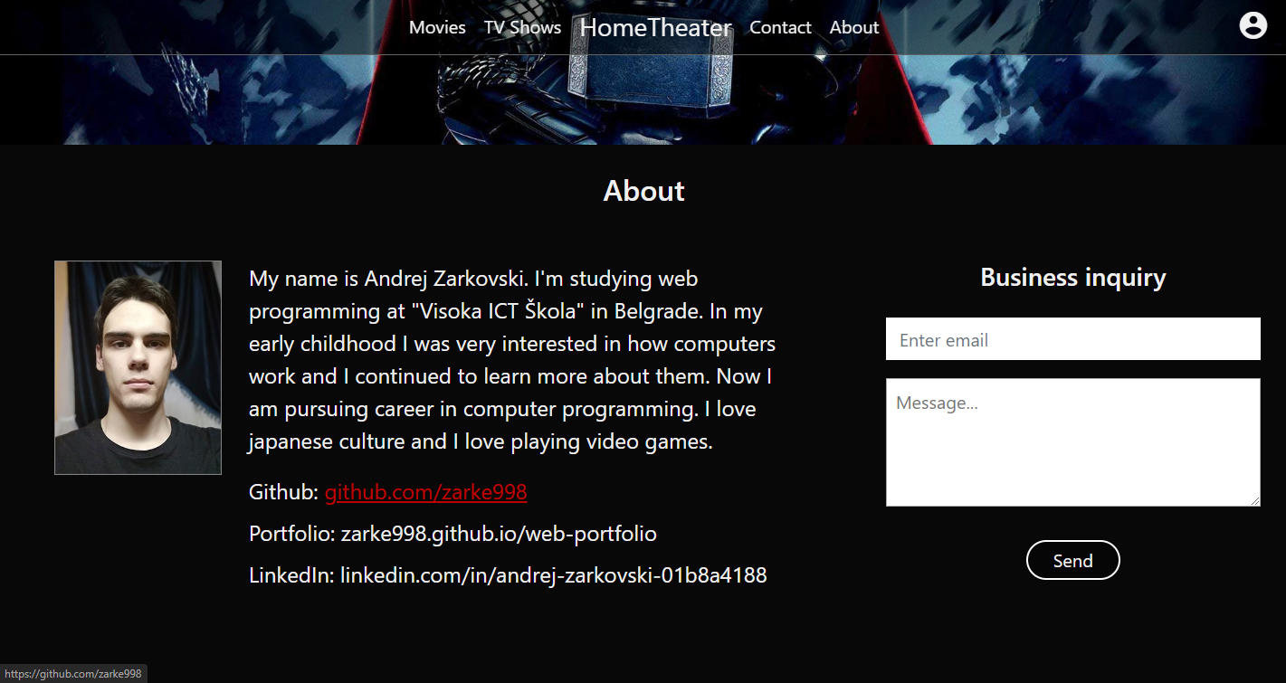

Na stranici o autoru sa leve strane nalazi slika, kratka izjava autora i linkovi ka bitnim stranicama koje se ticu autora.

A sa desne strane nalazi se forma za slanje biznis mejla autoru. Ponasanje forme je identicno kao na stranici za kontakt.

### bookmarks.php

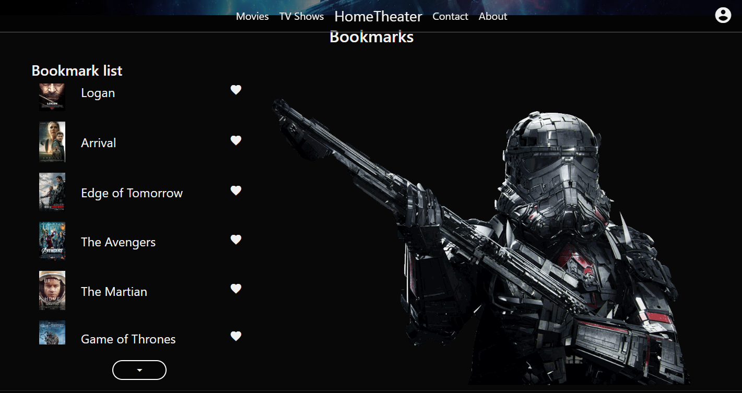

Stranica »Bookmarks« namenjena je samo autorizovanim korisnicima.

Na stranici se nalazi lista zapamcenih filmova/serija od strane korisnika.

Pored svakog filma/serije nalazi se srce, cijim se klikom film/serija brise iz bookmark liste.

Pri dnu liste se nalazi dugme za ucitavanje jos zapamcenih filmova/serija. Ukoliko nema dodatnih filmova/serija dugme se sakriva.

### manage_content_library.php

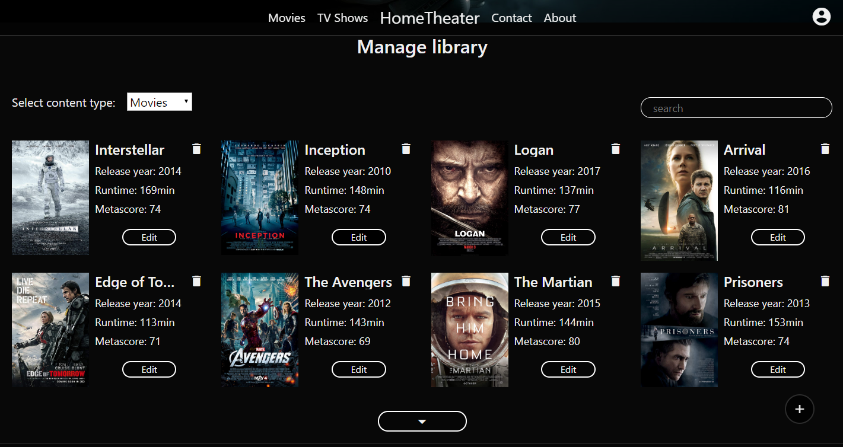

Ova stranica sluzi kao admin panel za unosenje, izmenu i brisanje sadrzaja biblioteke filmova/serija.

Na sredini stranice nalazi se lista sa sadrzajem sa osnovnim informacijama o sadrzaju (naslov, godina izdavanja itd.).

Na vrhu liste nalazi se filter sa tip sadrzaja, kao i tekstualno polje za pretragu sadrzaja po naslovu.

Na dnu liste nalazi se dugme za ucitavanje dodatnog sadrzaja.

Klikom da dugme u donjem desnom uglu otvara se dijalog za dodavanje novog sadrzaja u biblioteku kao na slici ispod.

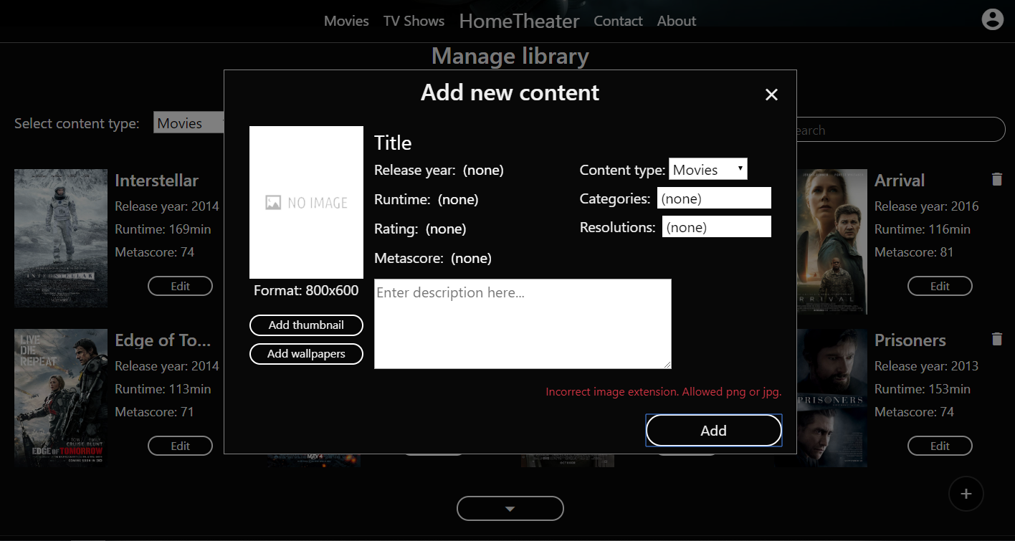

Na dijalogu se nalaze polja za ubacivanje slika, polja za unos osnovnih informacija o sadrzaju, kao i drop down liste za odabir razlicitih kategorija sadrzaja (tip sadrzaja, podkategorija, rezolucija).

Klikom na dugme »Add« sadrzaj se ubacuje u bazu podataka. U slucaju neispravnog formata nekih od polja za unos, ispisuje se greka iznad dugmeta kao na slici iznad.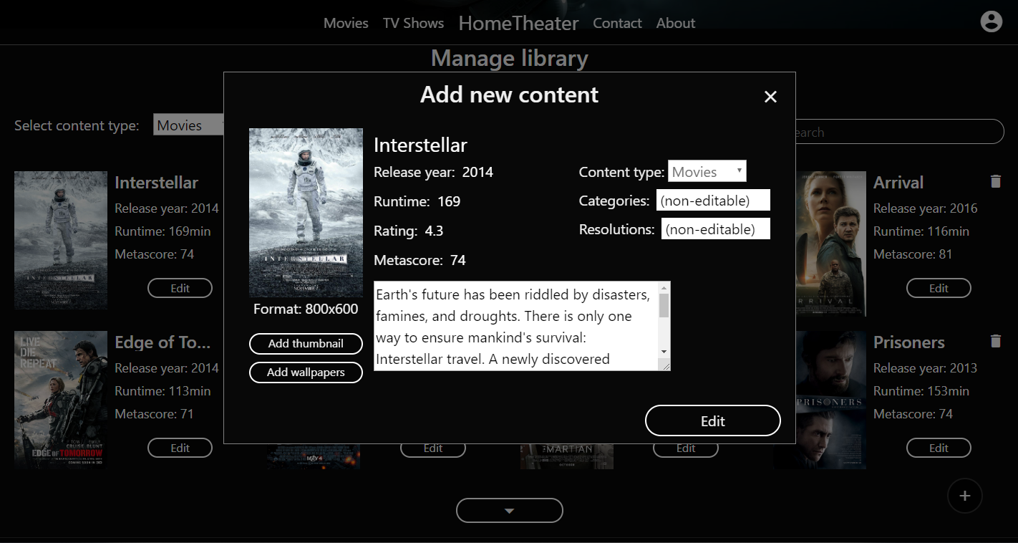

Klikom da dugme »Edit« kod stavke liste otvara se dijalog za izmenu sadrzaja pri cemu je omoguceno menjaje samo osnovnih informacija o sadrzaju: titl, godina izdavanja itd. (red u sredini).

Klikom ikonicu kante pored stavke u listi sadrzaj se brise iz baze podataka.

### login.php

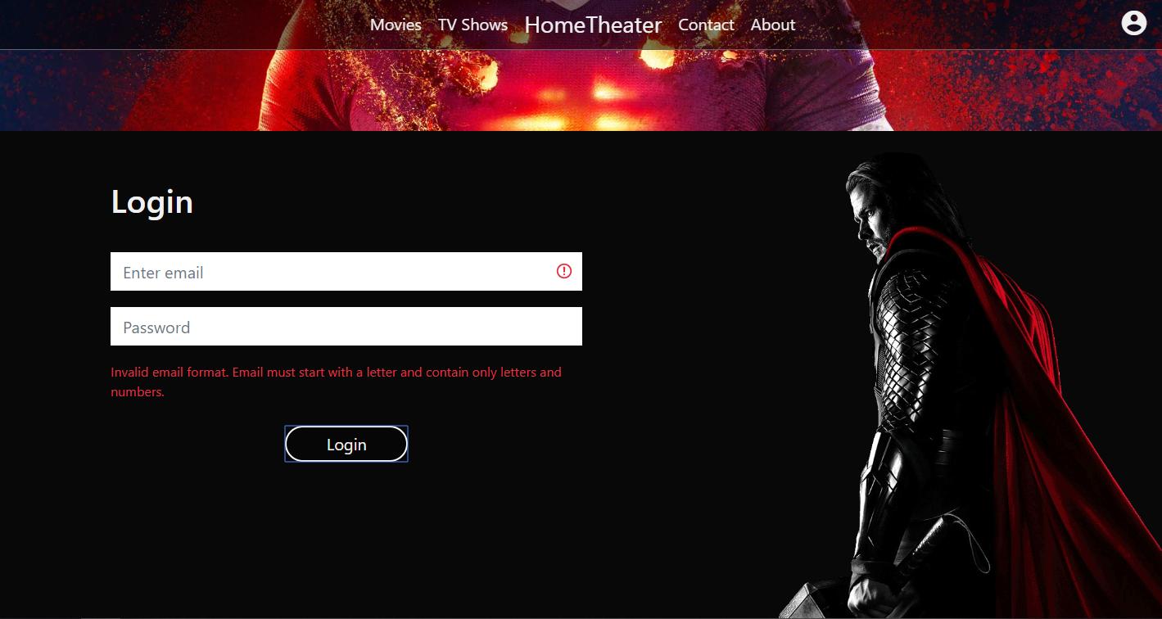

Stranica za logovanje autorizovanih korisnika.

Pri neuspelom logovanju ispisuje se poruka iznad dugmeta »Login« o tipu greske.

### register.php

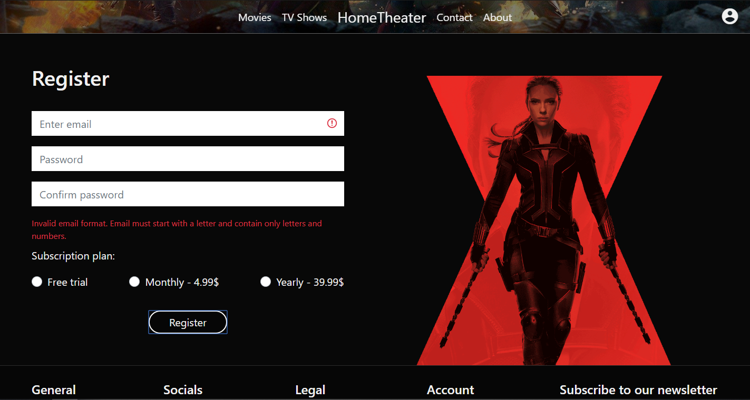

Stranica za registraciju korisnika.

Pri neuspeloj registraciji ispisuje se poruka ispod tekstualnih polja o tipu greske.

### 403.php

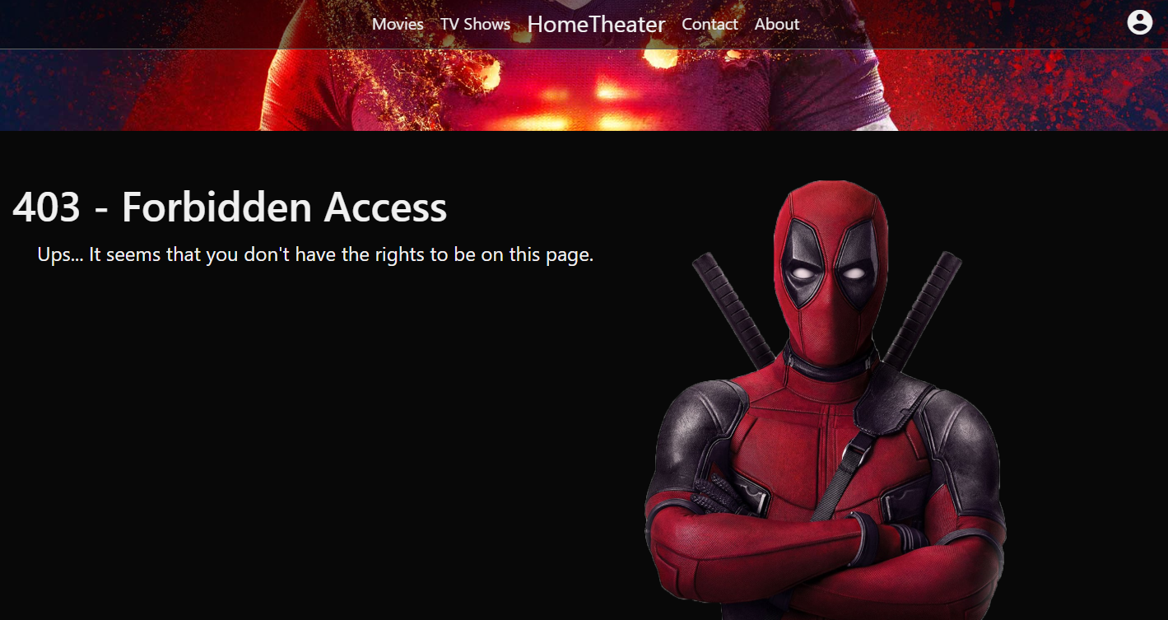

Stranica koja se prikazuje pri neautorizovanom pristupu stranicama *bookmarks.php* i *manage_content_library.php*.

# 3. Kodovi

## PHP

### index.php

<?php

    session_start();

    $pageTitle = "HomeTheater - Home";

    require_once "views/head.php";

    $headerText = "Cheap. <span>High quality. New.</span>";

    $isIntroSmaller = false;

    $introId = "indexIntro";

    require_once "views/header.php";

    require_once "views/index_content.php";

    $scripts = ["main.js","index.js"];

    if(isset($_SESSION["surveyMsg"])){

        $alertMsg = $_SESSION["surveyMsg"];

        unset($_SESSION["surveyMsg"]);

    }

    require_once "views/footer.php";

?>

### movies.php

<?php

    session_start();

    $pageTitle = "HomeTheater - Movies";

    require_once "views/head.php";

    $isIntroSmaller = true;

    $introId = "moviesIntro";

    require_once "views/header.php";

    require_once "views/movies_content.php";

    $scripts = ["main.js","content-list.js"];

    require_once "views/footer.php";

?>

### tvshows.php

<?php

    session_start();

    $pageTitle = "HomeTheater - TV Shows";

    require_once "views/head.php";

    $isIntroSmaller = true;

    $introId = "tvshowsIntro";

    require_once "views/header.php";

    require_once "views/tvshows_content.php";

    $scripts = ["main.js","content-list.js"];

    require_once "views/footer.php";

?>

### contact.php

<?php

    session_start();

    $pageTitle = "HomeTheater - Contact";

    require_once "views/head.php";

    $isIntroSmaller = true;

    $introId = "contactIntro";

    require_once "views/header.php";

    require_once "views/contact_content.php";

    $scripts = ["main.js","contact.js"];

    require_once "views/footer.php";

?>

### about.php

<?php

    session_start();

    $pageTitle = "HomeTheater - About";

    require_once "views/head.php";

    $isIntroSmaller = true;

    $introId = "aboutIntro";

    require_once "views/header.php";

    require_once "views/about_content.php";

    $scripts = ["main.js","about.js"];

    require_once "views/footer.php";

?>

### login.php

<?php

    session_start();

    if(isset($_SESSION["user"])){

        header("Location: index.php");

        exit;

    }

    $pageTitle = "HomeTheater - Login";

    require_once "views/head.php";

    $isIntroSmaller = true;

    $introId = "loginIntro";

    require_once "views/header.php";

    require_once "views/login_content.php";

    $scripts = ["main.js","login.js"];

    require_once "views/footer.php";

?>

### register.php

<?php

    session_start();

    if(isset($_SESSION["user"])){

        header("Location: index.php");

        exit;

    }

    $pageTitle = "HomeTheater - Login";

    require_once "views/head.php";

    $isIntroSmaller = true;

    $introId = "registerIntro";

    require_once "views/header.php";

    require_once "views/register_content.php";

    $scripts = ["main.js","register.js"];

    require_once "views/footer.php";

?>

### logout.php

<?php

    session_start();

    if(isset($_SESSION["user"])){

        session_unset();

        session_destroy();

    }

    header("Location: index.php");

    exit;

?>

### 403.php

<?php

    $pageTitle = "HomeTheater - 403";

    require_once "views/head.php";

    $isIntroSmaller = true;

    require_once "views/header.php";

    require_once "views/403_content.php";

    $scripts = ["main.js"];

    require_once "views/footer.php";

?>

### Authorized user pages

#### 

#### bookmarks.php

<?php

    session_start();

    if(!isset($_SESSION["user"])){

        header("Location: ../403.php");

        exit;

    }

    $pageTitle = "HomeTheater - Bookmarks";

    require_once "../views/head.php";

    $isIntroSmaller = true;

    $introId = "bookmarksIntro";

    require_once "../views/header.php";

    require_once "../views/bookmarks_content.php";

    $scripts = ["main.js","bookmarks.js"];

    require_once "../views/footer.php";

?>

#### manage_content_library.php

<?php

    session_start();

    if(!isset($_SESSION["user"]) or $_SESSION["user"]->role_id != 1){

        header("Location: ../403.php");

        exit;

    }

    $pageTitle = "HomeTheater - Manage content library";

    require_once "../views/head.php";

    $isIntroSmaller = true;

    $introId = "manageContentIntro";

    require_once "../views/header.php";

    require_once "../views/manage_content_library_content.php";

    $scripts = ["main.js","manage-content-library.js"];

    if(isset($_SESSION["addContentError"])){

        $alertMsg = $_SESSION["addContentError"];

        unset($_SESSION["addContentError"]);

    }

    else if(isset($_SESSION["addContentSuccess"])){

        $alertMsg = $_SESSION["addContentSuccess"];

        unset($_SESSION["addContentSuccess"]);

    }

    $isSurveyHidden = true;

    require_once "../views/footer.php";

?>

### Views

#### head.php

<!DOCTYPE html>

<html lang="en">

<head>

    <meta charset="UTF-8">

    <meta name="viewport" content="width=device-width, initial-scale=1.0">

    <title><?=$pageTitle?></title>

    <meta name="author" content="Andrej Zarkovski">

    <meta name="keywords" content="movies, tvshows, watch, online, 4K, new, cheap, high quality">

    <meta name="description" content="Watch movies, tv shows, cartoons and other content for a low price of just 4.99$/month.

                                    Our rich content library ensures you don't ever run out of content to watch. Stay up to date with latest

                                    movies as we upload them as soon as they become available for DVD. Come watch now!">

    <link rel="shortcut icon" href="favicon.png" type="image/png">

    <link href="https://fonts.googleapis.com/icon?family=Material+Icons" rel="stylesheet">

    <link rel="stylesheet" href="https://stackpath.bootstrapcdn.com/bootstrap/4.4.1/css/bootstrap.min.css" integrity="sha384-Vkoo8x4CGsO3+Hhxv8T/Q5PaXtkKtu6ug5TOeNV6gBiFeWPGFN9MuhOf23Q9Ifjh" crossorigin="anonymous">

    <link rel="stylesheet" type="text/css" href="/css/main.css" />

</head>

#### header.php

<?php

    if (session_status() == PHP_SESSION_NONE) {

        session_start();

    }

    $rootPath = $_SERVER["DOCUMENT_ROOT"];

    require_once "$rootPath/logic/menuFetcher.php";

    if(isset($_SESSION["user"]))

        $user = $_SESSION["user"];

    else

        $user = null;

?>

<body>

    <nav class="navbar navbar-expand-md navbar-light bg-light fixed-top py-0 navigationContainer">

        <button class="navbar-toggler navigationBtn" type="button" data-toggle="collapse" data-target="#navbarTogglerDemo03" aria-controls="navbarTogglerDemo03" aria-expanded="false" aria-label="Toggle navigation">

            <span class="material-icons">menu</span>

        </button>

        <a class="navbar-brand d-md-none mx-auto websiteTitle" href="/index.php">HomeTheater</a>

        <div class="account">

            <div>

                <i id="accountBtn" class="material-icons medium">account_circle</i>

                <?php

                    if($user != null): ?>

                <div class="accountPanel">

                    <div class="d-flex align-items-center accountInfo">

                        <i class="material-icons d-block">account_circle</i><span class="d-block ml-2 mb-1"><?php

                            echo explode("@",$user->email)[0];

                        ?> </span>

                    </div>

                    <ul class="accountLinks text-center mb-0">

                        <!-- <li><a href="#">Bookmark list</a></li> -->

                        <?php

                            $items = getMenuItems("authorized_acc_menu");

                            if($user->role_id == 1){

                                foreach($items as $i) {

                                    echo "<li><a href='$i->href'>$i->item_name</a></li>";

                                }

                            }

                            else{

                                foreach($items as $i) {

                                    if($i->role_id == $user->role_id){

                                        echo "<li><a href='$i->href'>$i->item_name</a></li>";

                                    }

                                }

                            }

                        ?>

                        <li class="border-top mt-2 pt-2">

                            <form action="/logout.php" method="GET">

                                <button type="submit" name="logoutBtn" value="on" id="logoutBtn" href="#">Logout</button>

                            </form>

                        </li>

                    </ul>

                </div>

                <?php else: ?>

                <div class="accountPanel">

                    <div class="d-flex align-items-center accountInfo">

                        <i class="material-icons d-block">account_circle</i><span class="d-block ml-2 mb-1"> Account </span>

                    </div>

                    <ul class="accountLinks text-center mb-0">

                        <li><a href="login.php">Login</a></li>

                        <li><a href="register.php">Register</a></li>

                    </ul>

                </div>

                <?php endif;?>

            </div>

        </div>

        <div class="collapse navbar-collapse" id="navbarTogglerDemo03">

            <ul class="navbar-nav mx-auto my-0 navigationMenu">

                <!-- <li class="nav-item">

                    <a class="nav-link" href="#">TV Shows</a>

                </li>

                <li class="nav-item d-none d-md-inline websiteTitle">

                    <a class="nav-link" href="#">HomeTheater</a>

                </li> -->

                <?php

                    $rootPath = $_SERVER["DOCUMENT_ROOT"];

                    require_once "$rootPath/logic/menuFetcher.php";

                    $items = getMenuItems("nav_menu");

                    for($i = 0; $i < (int)count($items)/2; $i++): ?>

                        <li class="nav-item">

                        <a class="nav-link" href="<?=$items[$i]->href?>"><?=$items[$i]->item_name?></a>

                    </li>

                    <?php endfor;

                    echo '<li class="nav-item d-none d-md-inline websiteTitle">

                            <a class="nav-link" href="/index.php">HomeTheater</a>

                        </li>';

                    for($i = count($items)/2; $i < count($items); $i++): ?>

                        <li class="nav-item">

                            <a class="nav-link" href="<?=$items[$i]->href?>"><?=$items[$i]->item_name?></a>

                        </li>

                    <?php endfor;

                ?>

            </ul>

        </div>

    </nav>

    <div id="<?php if(isset($introId)) echo "$introId";?>" class="intro<?php if(isset($isIntroSmaller) && $isIntroSmaller) echo " smallerIntro"; ?>">

        <?php

            if(isset($headerText)){

                echo "<h1>$headerText</h1>";

            }

        ?>

    </div>

#### footer.php

<?php

    if(session_status() == PHP_SESSION_NONE)

        session_start()

?>

    <div id="footer" class="container-fluid px-4 px-md-5 pt-4">

        <?php

        $rootPath = $_SERVER["DOCUMENT_ROOT"];

        require_once "$rootPath/logic/dbConnection.php";

        require_once "$rootPath/logic/SurveyLib.php";

        if(isset($_SESSION["user"])){

            $user = $_SESSION["user"];

            $surveys = getSurveys($user->id);

        }

        else

            $user = null;

        if(session_status() == PHP_SESSION_ACTIVE and isset($_SESSION["user"]) and !(isset($isSurveyHidden) and $isSurveyHidden) and count($surveys) > 0) :?>

        <div class="surveyPanel accordion" id="accordionExample">

            <?php

                foreach($surveys as $s): ?>

                <div class="card">

                    <div class="card-header p-1" id="heading<?=$s->info->id?>">

                        <h5 class="mb-0">

                            <button class="btn btn-link" type="button" data-toggle="collapse" data-target="#collapse<?=$s->info->id?>" aria-expanded="false" aria-controls="collapse<?=$s->info->id?>">

                            <?=$s->info->name?>

                            </button>

                        </h5>

                    </div>

                    <div id="collapse<?=$s->info->id?>" class="collapse" aria-labelledby="heading<?=$s->info->id?>" data-parent="#accordionExample">

                        <form action="/logic/survey_processor.php" method="POST" onsubmit="return validateSurvey()">

                            <div class="card-body">

                                <?php

                                    $questionIndex = 1;

                                    foreach($s->questions as $q): ?>

                                    <div class="surveyQuestion mb-4">

                                    <p>

                                        <?php

                                            $questionName = $q->info->name;

                                            echo "$questionIndex. $questionName";

                                            $questionIndex++;

                                        ?>

                                    </p>

                                    <?php foreach($q->answers as $a): ?>

                                    <?php $answerId = $a->id;

                                          $answerName = $a->name; ?>

                                     <div class="custom-control custom-radio">

                                        <input type="radio" id="customRadio<?=$answerId?>" name="customRadio<?=$q->info->id?>" value="<?=$a->id?>" class="custom-control-input">

                                        <label class="custom-control-label" for="customRadio<?=$answerId?>"><?=$answerName?></label>

                                    </div>

                                    <?php endforeach; ?>

                                </div>

                                    <?php endforeach;

                                        echo "<input id='loginBtn' type='submit' name='surveyBtn' value='Send' class='d-block mx-auto w-25 mt-4 ht-btn sendSurveyAnswersBtn' />";

                                    ?>

                            </div>

                        </form>

                    </div>

                </div>

            <?php endforeach; ?>

        </div>

        <div class="surveyBtn">

            <i class="material-icons">assignment</i>

        </div>

        <?php endif;?>

        <div class="row">

            <div class="col-12 col-md-7 col-lg-9">

                <div class="row footerList text-center text-md-left">

                    <div class="col-6 col-lg-3">

                        <h3>General</h3>

                        <ul>

                        <?php

                            $rootPath = $_SERVER["DOCUMENT_ROOT"];

                            require_once "$rootPath/logic/menuFetcher.php";

                            $items = getMenuItems("nav_menu");

                            for($i = 0; $i < count($items); $i++): ?>

                            <li>

                                <a href="<?=$items[$i]->href?>"><?=$items[$i]->item_name?></a>

                            </li>

                            <?php endfor;

                        ?>

                        </ul>

                    </div>

                    <div class="col-6 col-lg-3">

                        <h3>Socials</h3>

                        <ul>

                        <?php

                            $rootPath = $_SERVER["DOCUMENT_ROOT"];

                            require_once "$rootPath/logic/menuFetcher.php";

                            $items = getMenuItems("socials_menu");

                            for($i = 0; $i < count($items); $i++): ?>

                            <li>

                                <a href="<?=$items[$i]->href?>"><?=$items[$i]->item_name?></a>

                            </li>

                            <?php endfor;

                        ?>

                        </ul>

                    </div>

                    <div class="col-6 col-lg-3">

                        <h3>Legal</h3>

                        <ul>

                        <?php

                            $rootPath = $_SERVER["DOCUMENT_ROOT"];

                            require_once "$rootPath/logic/menuFetcher.php";

                            $items = getMenuItems("legal_menu");

                            for($i = 0; $i < count($items); $i++): ?>

                            <li>

                                <a href="<?=$items[$i]->href?>"><?=$items[$i]->item_name?></a>

                            </li>

                            <?php endfor;

                        ?>

                        </ul>

                    </div><div class="col-6 col-lg-3">

                        <h3>Account</h3>

                        <ul>

                        <?php

                            $rootPath = $_SERVER["DOCUMENT_ROOT"];

                            require_once "$rootPath/logic/menuFetcher.php";

                            $items = getMenuItems("account_footer_menu");

                            for($i = 0; $i < count($items); $i++): ?>

                            <li>

                                <a href="<?=$items[$i]->href?>"><?=$items[$i]->item_name?></a>

                            </li>

                            <?php endfor;

                        ?>

                        </ul>

                    </div>

                </div>

            </div>

            <div class="col-12 col-md-5 col-lg-3 px-2 px-sm-5 px-md-1 newsletterContainer mb-2">

                <h3 class="text-center">Subscribe to our newsletter</h3>

                <form class="mt-4 pt-2">

                    <div class="input-group input-group-sm border-0 newsletterForm">

                        <input type="email" class="form-control border-0 rounded-0" id="loginEmail" aria-describedby="emailHelp" placeholder="Enter email">

                        <div class="input-group-append">

                            <i class="input-group-text material-icons sendIcon">send</i>

                         </div>

                        <!-- <small id="emailHelp" class="form-text text-muted">We'll never share your email with anyone else.</small> -->

                    </div>

                </form>

            </div>

        </div>

        <p id="copyright" class="text-center mb-2">Copyright &copy; | HomeTheater <?php echo date("Y")?>. All rights reserved.</p>

    </div>

    <script src="https://ajax.googleapis.com/ajax/libs/jquery/3.4.1/jquery.min.js"></script>

    <script src="/js/jquery.nicescroll.min.js"></script>

    <script src="https://cdn.jsdelivr.net/npm/popper.js@1.16.0/dist/umd/popper.min.js" integrity="sha384-Q6E9RHvbIyZFJoft+2mJbHaEWldlvI9IOYy5n3zV9zzTtmI3UksdQRVvoxMfooAo" crossorigin="anonymous"></script>

    <script src="https://stackpath.bootstrapcdn.com/bootstrap/4.4.1/js/bootstrap.min.js" integrity="sha384-wfSDF2E50Y2D1uUdj0O3uMBJnjuUD4Ih7YwaYd1iqfktj0Uod8GCExl3Og8ifwB6" crossorigin="anonymous"></script>

    <?php

        if(isset($scripts))

        {

            foreach($scripts as $s): ?>

                <script src="/js/<?=$s?>"></script>

            <?php endforeach;

        }

        if(isset($alertMsg)): ?>

            <script type="text/javascript">

                window.onload = function(){

                    alert("<?=$alertMsg?>");

                }

            </script>

        <?php endif;

    ?>

</body>

</html>

<?php

    function getSurveys($userId){

        global $conn;

        $surveys = [];

        $surveysQuery = "SELECT * FROM surveys

        WHERE isActive = 1 AND id NOT IN(SELECT s.id FROM surveys AS s

                                         INNER JOIN survey_questions AS s_q ON s_q.survey_id = s.id

                                         INNER JOIN survey_question_answers AS s_q_a ON s_q_a.survey_question_id = s_q.id

                                         INNER JOIN user_survey_answers AS u_s_a ON u_s_a.survey_question_answer_id = s_q_a.id

                                         WHERE u_s_a.user_id = :user)";

        $surveyStm = $conn->prepare($surveysQuery);

        $surveyStm->bindParam(":user",$userId);

        $surveyStm->execute();

        while($s = $surveyStm->fetch()){

            $survey = new Survey();

            $survey->info = $s;

            $questionsQuery = "SELECT * FROM survey_questions WHERE survey_id=:id";

            $questionsStm = $conn->prepare($questionsQuery);

            $questionsStm->bindParam(":id", $s->id);

            $questionsStm->execute();

            while($q = $questionsStm->fetch()){

                $surveyQuestion = new SurveyQuestion();

                $surveyQuestion->info = $q;

                $answersQuery = "SELECT * FROM survey_question_answers WHERE survey_question_id=:id";

                $answersStm = $conn->prepare($answersQuery);

                $answersStm->bindParam(":id",$q->id);

                $answersStm->execute();

                while($a = $answersStm->fetch()){

                    $surveyQuestion->answers[] = $a;

                }

                $survey->questions[] = $surveyQuestion;

            }

            $surveys[] = $survey;

        }

        return $surveys;

    }

?>

#### index_content.php

<?php

    $rootPath = $_SERVER["DOCUMENT_ROOT"];

    require_once "$rootPath/logic/dbConnection.php";

    if(isset($_SESSION["user"])){

        $user = $_SESSION["user"];

        $movieCategories = getAvailableContentCategories(1);

        $tvShowCategories = getAvailableContentCategories(2);

    }

    else

        $user = null;

?>

<div class="container-fluid py-5 d-flex flex-column">

    <?php

        if($user == null)

            $order = "1";

        else

            $order = "6";

    ?>

    <div class="contentListContainer mb-5 px-1 order-<?php echo $order ?>">

        <h2 class="mb-4 text-center text-sm-left">Most popular Movies</h2>

        <div class="contentListWrapper">

            <div class="contentList d-flex">

            <?php

                    $movies = getMostPopularContent(1,false);

                    foreach($movies as $m): ?>

                    <div class="contentListItem">

                        <img src="<?=substr($m->file_path,3)?>" alt="Cover">

                        <div class="contentOverlay">

                        <?php

                            if($user != null){

                                if($m->user != null)

                                    echo "<i data-id='$m->con_id'class='material-icons favoriteBtn'>favorite</i>";

                                else

                                    echo "<i data-id='$m->con_id'class='material-icons favoriteBtn'>favorite_border</i>";

                            }

                                // <i class="material-icons">favorite</i>

                        ?>

                            <div class="contentInfo">

                                <p><?=$m->title?></p>

                                <p><?=$m->rating?> <i class="material-icons ml-1">star</i></p>

                            </div>

                        </div>

                    </div>

                    <?php endforeach;

            ?>

            </div>

            <div class="contentListScroll contentListScrollLeft" data-dir="-1"><i class="material-icons">keyboard_arrow_left</i></div>

            <div class="contentListScroll contentListScrollRight" data-dir="1"><i class="material-icons">keyboard_arrow_right</i></div>

        </div>

    </div>

    <?php

        if($user == null)

            $order = "2";

        else

            $order = "7";

    ?>

    <div class="contentListContainer mb-4 px-1 order-<?php echo $order ?>">

        <h2 class="mb-4 text-center text-sm-left">Most popular TV Shows</h2>

        <div class="contentListWrapper">

            <div class="contentList d-flex">

            <?php

                    $tvShows = getMostPopularContent(2,false);

                    foreach($tvShows as $tS): ?>

                    <div class="contentListItem">

                        <img src="<?=substr($tS->file_path,3)?>" alt="Cover">

                        <div class="contentOverlay">

                            <?php

                                if($user != null){

                                    if($tS->user != null)

                                        echo "<i data-id='$tS->con_id'class='material-icons favoriteBtn'>favorite</i>";

                                    else

                                        echo "<i data-id='$tS->con_id'class='material-icons favoriteBtn'>favorite_border</i>";

                                }

                                    // <i class="material-icons">favorite</i>

                            ?>

                            <div class="contentInfo">

                                <p><?=$tS->title?></p>

                                <p><?=$tS->rating?> <i class="material-icons ml-1">star</i></p>

                            </div>

                        </div>

                    </div>

                    <?php endforeach;

            ?>

            </div>

            <div class="contentListScroll contentListScrollLeft" data-dir="-1"><i class="material-icons">keyboard_arrow_left</i></div>

            <div class="contentListScroll contentListScrollRight" data-dir="1"><i class="material-icons">keyboard_arrow_right</i></div>

        </div>

    </div>

    <?php

        if($user == null): ?>

    <div id="freeTrialContainer" class="row px-3 px-sm-5 py-5 order-3">

        <div class="col-md-7 col-lg-6 px-0">

            <h2 class="text-center mb-5">Start your Free Trial</h2>

            <ul>

                <li class="mb-2"><i class="material-icons mr-3 ">play_circle_filled</i><span>7 day Free Trial</span></li>

                <li class="mb-2"><i class="material-icons mr-3 ">play_circle_filled</i><span>Gain access to all features</span></li>

                <li class="mb-2"><i class="material-icons mr-3 ">play_circle_filled</i><span>After that you can subscribe for only 4.99$/month</span></li>

            </ul>

            <button type="button" class="ht-btn d-block mx-auto py-0" disabled>Free trial</button>

        </div>

        <div class="col-6"></div>

    </div>

    <?php endif; ?>

    <div class="contentListContainer mb-5 mt-4 px-1 order-4">

        <h2 class="mb-4 text-center text-sm-left">4K Movies</h2>

        <div class="contentListWrapper">

            <div class="contentList d-flex">

            <?php

                    $movies = getContentByResolution(1,2);

                    foreach($movies as $m): ?>

                    <div class="contentListItem">

                        <img src="<?=substr($m->file_path,3)?>" alt="Cover">

                        <div class="contentOverlay">

                            <?php

                                if($user != null){

                                    if($m->user != null)

                                        echo "<i data-id='$m->con_id'class='material-icons favoriteBtn'>favorite</i>";

                                    else

                                        echo "<i data-id='$m->con_id'class='material-icons favoriteBtn'>favorite_border</i>";

                                }

                                    // <i class="material-icons">favorite</i>

                            ?>

                            <div class="contentInfo">

                                <p><?=$m->title?></p>

                                <p><?=$m->rating?> <i class="material-icons ml-1">star</i></p>

                            </div>

                        </div>

                    </div>

                    <?php endforeach;

            ?>

            </div>

            <div class="contentListScroll contentListScrollLeft" data-dir="-1"><i class="material-icons">keyboard_arrow_left</i></div>

            <div class="contentListScroll contentListScrollRight" data-dir="1"><i class="material-icons">keyboard_arrow_right</i></div>

        </div>

    </div>

    <?php

        if($user == null)

            $order = "5";

        else

            $order = "3";

    ?>

    <div id="newReleasesContainer" class="row py-4 order-<?php echo $order?>">

        <div id="newReleasesBackground"></div>

        <div class="col-12 mb-4">

            <h2 class="text-center mb-5">New releases</h2>

        </div>

        <div class="col-1"></div>

        <div class="col-12 col-md-8">

            <div id="newReleases" class="row">

                <div class="col-10 offset-1 col-md-6 offset-md-0 px-0">

                    <div class="row d-flex align-items-center justify-content-between">

                        <div data-dir="-1" class="col-1 contentListScroll contentListScrollLeft px-0">

                            <i class="material-icons">keyboard_arrow_left</i>

                        </div>

                        <div id="sliderItemCover" class="col-10 px-3">

                            <img src="images/no-image.jpg" class="w-100" alt="Cover">

                        </div>

                        <div data-dir="1" class="col-1 contentListScroll contentListScrollRight px-0">

                            <i class="material-icons">keyboard_arrow_right</i>

                        </div>

                    </div>

                </div>

                <div id="sliderItemInfo" class="col-12 col-md-6">

                    <h4 class="mt-3 mt-md-0 mb-4 text-center text-md-left">Deadpool</h4>

                    <p class="text-center text-md-left">This is a description.. This is a description.. This is a description.. This is a description.. This is a description.. This is a description.. This is a description.. This is a description.. This is a description.. This is a description.. This is a description.. This is a description.. This is a description.. This is a description.. This is a description.. </p>

                    <button type="button" class="ht-btn d-block mx-auto" disabled> Watch now</button>

                </div>

            </div>

        </div>

    </div>

    <?php

        if($user == null){

            $order = "6";

        }

        if($user == null): ?>

    <div id="promoContainer" class="d-flex justify-content-between align-items-center px-4 py-2 order-<?=$order?>">

        <p class="mb-0">Have a promo code? Get 3 months of free subscription, and watch anything you want.</p>

        <button type="button" class="ht-yellow-btn">Enter code now!</button>

    </div>

    <?php endif; ?>

    <?php

        if($user == null)

            $order = "7";

        else

            $order = "5";

    ?>

    <div id="mobileAppContainer" class="row mb-5 px-3 px-md-5 py-5 order-<?=$order?>">

        <img id="mobileDecoration" src="images/phone-frame.png" alt="Decoration" ></img>

        <div id="mobileInfo"class="col-12 col-md-8">

            <h2 class="mb-4">Download our mobile app!</h2>

            <p>Take our content library anywhere with you, by scaning qr code with your phone or going to the play store directly via button below.</p>

            <div class="row">

                <div id="mobileInfoDetails" class="col-12 col-md-6">

                    <p>Benefits of installing mobile app:</p>

                    <ul>

                        <li class="mb-2"><i class="material-icons mr-3 ">play_circle_filled</i><span>7 day Free Trial</span></li>

                        <li class="mb-2"><i class="material-icons mr-3 ">play_circle_filled</i><span>Gain access to all features</span></li>

                        <li class="mb-2"><i class="material-icons mr-3 ">play_circle_filled</i><span>After that you can subscribe for only 4.99$/month</span></li>

                    </ul>

                    <button type="button" class="ht-btn mx-auto py-0" disabled>Go to Play Store</button>

                </div>

            </div>

        </div>

        <div class="col-4"></div>

    </div>

    <?php

        if($user == null){

            $order = "8";

        }

        if($user == null): ?>

    <div class="contentListContainer mb-5 px-1 order-<?=$order?>">

        <h2 class="mb-4 text-center text-sm-left">Best rated Movies by critics</h2>

        <div class="contentListWrapper">

            <div class="contentList d-flex">

            <?php

                    $movies = getMostPopularContent(1,true);

                    foreach($movies as $m): ?>

                    <div class="contentListItem">

                        <img src="<?=substr($m->file_path,3)?>" alt="Cover">

                        <div class="contentOverlay">

                            <?php

                                if($user != null){

                                    if($m->user != null)

                                        echo "<i data-id='$m->con_id'class='material-icons favoriteBtn'>favorite</i>";

                                    else

                                        echo "<i data-id='$m->con_id'class='material-icons favoriteBtn'>favorite_border</i>";

                                }

                                    // <i class="material-icons">favorite</i>

                            ?>

                            <div class="contentInfo">

                                <p><?=$m->title?></p>

                                <p><?=$m->rating?> <i class="material-icons ml-1">star</i></p>

                            </div>

                        </div>

                    </div>

                    <?php endforeach;

            ?>

            </div>

            <div class="contentListScroll contentListScrollLeft" data-dir="-1"><i class="material-icons">keyboard_arrow_left</i></div>

            <div class="contentListScroll contentListScrollRight" data-dir="1"><i class="material-icons">keyboard_arrow_right</i></div>

        </div>

    </div>

    <?php endif; ?>

    <!-- authorized -->

    <?php

        if($user != null and count($movieCategories) > 0){

            $randCat = rand(0, count($movieCategories) - 1);

            $catId = $movieCategories[$randCat]->cat_id;

            $catName = $movieCategories[$randCat]->cat_name;

        }

        if($user != null and count($movieCategories) > 0) : ?>

    <div class="contentListContainer mb-5 px-1 order-1">

        <h2 class="mb-4 text-center text-sm-left">Best Movies - <?=$catName?></h2>

        <div class="contentListWrapper">

            <div class="contentList d-flex">

                <?php

                    $movies = getContentByCategory(1, $catId);

                    foreach($movies as $m): ?>

                    <div class="contentListItem">

                        <img src="<?=substr($m->file_path,3)?>" alt="Cover">

                        <div class="contentOverlay">

                            <?php

                                if($user != null){

                                    if($m->user != null)

                                        echo "<i data-id='$m->con_id'class='material-icons favoriteBtn'>favorite</i>";

                                    else

                                        echo "<i data-id='$m->con_id'class='material-icons favoriteBtn'>favorite_border</i>";

                                }

                                    // <i class="material-icons">favorite</i>

                            ?>

                            <div class="contentInfo">

                                <p><?=$m->title?></p>

                                <p><?=$m->rating?> <i class="material-icons ml-1">star</i></p>

                            </div>

                        </div>

                    </div>

                    <?php endforeach;

            ?>

            </div>

            <div class="contentListScroll contentListScrollLeft" data-dir="-1"><i class="material-icons">keyboard_arrow_left</i></div>

            <div class="contentListScroll contentListScrollRight" data-dir="1"><i class="material-icons">keyboard_arrow_right</i></div>

        </div>

    </div>

    <?php endif; ?>

    <?php

        if($user != null and count($tvShowCategories) > 0) {

            $randCat = rand(0, count($tvShowCategories) - 1);

            $catId = $tvShowCategories[$randCat]->cat_id;

            $catName = $tvShowCategories[$randCat]->cat_name;

        }

        if($user != null and count($tvShowCategories) > 0):

         ?>

    <div class="contentListContainer mb-5 px-1 order-2">

        <h2 class="mb-4 text-center text-sm-left">Best TV Shows - <?=$catName?></h2>

        <div class="contentListWrapper">

            <div class="contentList d-flex">

                <?php

                    $tvShows = getContentByCategory(2, $catId);

                    foreach($tvShows as $tS): ?>

                    <div class="contentListItem">

                        <img src="<?=substr($tS->file_path,3)?>" alt="Cover">

                        <div class="contentOverlay">

                            <?php

                                if($user != null){

                                    if($tS->user != null)

                                        echo "<i data-id='$tS->con_id'class='material-icons favoriteBtn'>favorite</i>";

                                    else

                                        echo "<i data-id='$tS->con_id'class='material-icons favoriteBtn'>favorite_border</i>";

                                }

                                    // <i class="material-icons">favorite</i>

                            ?>

                            <div class="contentInfo">

                                <p><?=$tS->title?></p>

                                <p><?=$tS->rating?> <i class="material-icons ml-1">star</i></p>

                            </div>

                        </div>

                    </div>

                    <?php endforeach;

            ?>

            </div>

            <div class="contentListScroll contentListScrollLeft" data-dir="-1"><i class="material-icons">keyboard_arrow_left</i></div>

            <div class="contentListScroll contentListScrollRight" data-dir="1"><i class="material-icons">keyboard_arrow_right</i></div>

        </div>

    </div>

    <?php endif; ?>

</div>

<?php

    function getContentByCategory($contentType,$category){

        global $conn;

        global $user;

        $bookmarksJoin = "";

        $bookmarksFilter = "";

        $bookmarksColumn = "";

        if($user != null){

            $bookmarksJoin = "LEFT JOIN (SELECT content_id, user_id FROM user_bookmarks WHERE user_id = :user) AS bookmarks

                                ON bookmarks.content_id = content.id";

            $bookmarksColumn = ",bookmarks.user_id AS user";

        }

        $selectQuery = "SELECT content.id AS con_id, title, rating, file_path $bookmarksColumn FROM content

                        INNER JOIN content_categories AS con_cat ON con_cat.content_id=content.id

                        INNER JOIN content_images AS con_img ON con_img.content_id = content.id

                        $bookmarksJoin

                        WHERE content_types_id=:contentType AND isCover=1 AND con_cat.category_id=:category

                        LIMIT 25 OFFSET 0;";

        $stm = $conn->prepare($selectQuery);

        $stm->bindParam(":contentType", $contentType);

        $stm->bindParam(":category", $category);

        if($user != null)

            $stm->bindParam(":user", $user->id);

        $stm->execute();

        return $stm->fetchAll();

    }

    function getAvailableContentCategories($contentType){

        global $conn;

        $selectQuery = "SELECT DISTINCT category_id AS cat_id, categories.name AS cat_name FROM content_categories

                        INNER JOIN content ON content.id = content_categories.content_id

                        INNER JOIN categories ON categories.id=content_categories.category_id

                        WHERE content_types_id = :contentType;";

        $stm = $conn->prepare($selectQuery);

        $stm->bindParam(":contentType", $contentType);

        $stm->execute();

        return $stm->fetchAll();

        }

    function getContentByResolution($contentType, $resolution){

        global $user;

        global $conn;

        $bookmarksJoin = "";

        $bookmarksFilter = "";

        $bookmarksColumn = "";

        if($user != null){

            $bookmarksJoin = "LEFT JOIN (SELECT content_id, user_id FROM user_bookmarks WHERE user_id = :user) AS bookmarks

                                ON bookmarks.content_id = content.id";

            $bookmarksColumn = ",bookmarks.user_id AS user";

        }

        $selectQuery = "SELECT content.id AS con_id, title, rating, file_path $bookmarksColumn FROM content

                        INNER JOIN content_resolutions AS con_res ON con_res.content_id = content.id

                        INNER JOIN content_images AS con_img ON con_img.content_id = content.id

                        $bookmarksJoin

                        WHERE content_types_id=:contentType AND isCover=1 AND con_res.resolution_id=:resolution

                        LIMIT 25 OFFSET 0;";

        $stm = $conn->prepare($selectQuery);

        $stm->bindParam(":contentType",$contentType);

        $stm->bindParam(":resolution",$resolution);

        if($user != null)

            $stm->bindParam(":user", $user->id);

        $stm->execute();

        return $stm->fetchAll();

    }

    function getMostPopularContent($contentType, $byCritics){

        // die("blabla");

        // if(isset($_GET["contentType"])){

        //     http_response_code(400);

        //     die("Incomplete input data.");

        // }

        // $contentType = $_GET["contentType"];

        global $conn;

        global $user;

        if($byCritics)

            $orderCrit = "metascore";

        else

            $orderCrit = "rating";

        $bookmarksJoin = "";

        $bookmarksFilter = "";

        $bookmarksColumn = "";

        if($user != null){

            $bookmarksJoin = "LEFT JOIN (SELECT content_id, user_id FROM user_bookmarks WHERE user_id = :user) AS bookmarks

                                ON bookmarks.content_id = content.id";

            $bookmarksColumn = ", bookmarks.user_id AS user";

        }

        $selectQuery = "SELECT content.id AS con_id, title, rating, file_path $bookmarksColumn FROM content

                        INNER JOIN content_images AS con_img ON con_img.content_id = content.id

                        $bookmarksJoin

                        WHERE content_types_id=:contentType AND isCover=1

                        ORDER BY $orderCrit DESC

                        LIMIT 25 OFFSET 0;";

        $stm = $conn->prepare($selectQuery);

        $stm->bindParam(":contentType",$contentType);

        if($user != null)

            $stm->bindParam(":user", $user->id);

        $stm->execute();

        return $stm->fetchAll();

        // header("Content-Type: application/json");

        // echo json_encode($result);

        }

?>

#### movies_content.php

<?php

    require_once "logic/dbConnection.php";

?>

<div id="moviesContainer" class="container-fluid px-3">

    <h1 class="text-center mt-3 mb-5">Movies</h1>

    <div id="contentFilters" class="row mb-4">

        <div class="col-sm-6 offset-sm-6 col-md-5 offset-md-7 col-lg-3 offset-lg-9 mb-2">

            <input class="d-block ml-0 w-100 ml-sm-auto" type="search" id="search" placeholder="search">

        </div>

        <div class="d-flex align-items-center col-12 col-sm-6 mb-2">

            <label class="mb-0">Select category: </label>

            <select id="contentCategoriesSelect" class="ml-3">

                <?php

                    $rootPath = $_SERVER["DOCUMENT_ROOT"];

                    require_once "$rootPath/logic/getAllCategories.php";

                    var_dump($categories);

                    echo "<option value='0'>All</option>";

                    foreach($categories as $c): ?>

                        <option value="<?=$c->id?>"><?=$c->name?></option>

                    <?php endforeach;

                ?>

            </select>

        </div>

        <div class="p-0 col-auto col-md-2"></div>

        <div class="col-12 col-sm-6 col-md-4 d-flex align-items-center justify-content-sm-end justify-content-start">

            <label class="mb-0">Sort by: </label>

            <select id="contentSortSelect" class="ml-3">

                <option value="1">Name A-Z</option>

                <option value="2">Name Z-A</option>

                <option value="3">Rating</option>

                <option value="4">Year ascending</option>

                <option value="5">Year descending</option>

            </select>

        </div>

    </div>

    <div id="contentListFull" data-contenttype="1" class="row mt-2 mb-3">

    </div>

    <button id="loadMoreContent" type="button" class="ht-btn mx-auto my-3"><i class="material-icons">arrow_drop_down</i></button>

</div>

#### tvshows_content.php

<?php

    require_once "logic/dbConnection.php";

?>

<div id="moviesContainer" class="container-fluid px-3">

    <h1 class="text-center mt-3 mb-5">TV Shows</h1>

    <div id="contentFilters" class="row mb-4">

        <div class="col-sm-6 offset-sm-6 col-md-5 offset-md-7 col-lg-3 offset-lg-9 mb-2">

            <input class="d-block ml-sm-auto" type="search" id="search" placeholder="search">

        </div>

        <div class="d-flex align-items-center col-12 col-sm-6 mb-2">

            <label class="mb-0">Select category: </label>

            <select id="contentCategoriesSelect" class="ml-3">

                <?php

                    $rootPath = $_SERVER["DOCUMENT_ROOT"];

                    require_once "$rootPath/logic/getAllCategories.php";

                    var_dump($categories);

                    echo "<option value='0'>All</option>";

                    foreach($categories as $c): ?>

                        <option value="<?=$c->id?>"><?=$c->name?></option>

                    <?php endforeach;

                ?>

            </select>

        </div>

        <div class="p-0 col-auto col-md-2"></div>

        <div class="col-12 col-sm-6 col-md-4 d-flex align-items-center justify-content-sm-end justify-content-start">

            <label class="mb-0">Sort by: </label>

            <select id="contentSortSelect" class="ml-3">

                <option value="1">Name A-Z</option>

                <option value="2">Name Z-A</option>

                <option value="3">Rating</option>

                <option value="4">Year ascending</option>

                <option value="5">Year descending</option>

            </select>

        </div>

    </div>

    <div id="contentListFull" data-contenttype="2" class="row mt-2 mb-3">

    </div>

    <button id="loadMoreContent" type="button" class="ht-btn mx-auto my-3"><i class="material-icons">arrow_drop_down</i></button>

</div>

#### login_content.php

<div id="loginContainer" class="container-fluid py-5 position-relative">

    <div class="row mx-0">

        <div class="col-md-7 col-lg-6 px-3 px-sm-5 ml-md-0 ml-md-5">

            <h2>Login</h2>

            <form class="mt-4 pt-2">

                <div class="form-group border-0">

                    <input type="email" class="form-control border-0 rounded-0" id="loginEmail" aria-describedby="emailHelp" placeholder="Enter email">

                </div>

                <div class="form-group">

                    <input type="password" class="form-control border-0 rounded-0" id="loginPassword" placeholder="Password">

                </div>

                <div id="loginFeedback" class="invalid-feedback d-none"></div>

                <!-- <div class="custom-control custom-checkbox">

                    <input type="checkbox" class="custom-control-input" id="loginRememberMe">

                    <label class="custom-control-label" for="loginRememberMe">Remember me</label>

                </div> -->

                <button id="loginBtn" type="button" class="d-block mx-auto mt-4 ht-btn">Login</button>

            </form>

        </div>

    </div>

    <img id="loginDecoration" src="images/thor-alpha.png" alt="Decoration image"/>

</div>

#### register_content.php

<div id="registerContainer" class="container-fluid py-5 position-relative">

    <div class="row">

        <div class="col-md-6 col-lg-5 px-3 px-sm-4 px-md-0 ml-0 ml-md-5">

            <h2>Register</h2>

            <form class="mt-4 pt-2">

                <div class="form-group border-0">

                    <input type="email" class="form-control border-0 rounded-0" id="registerEmail" aria-describedby="emailHelp" placeholder="Enter email">

                </div>

                <div class="form-group">

                    <input type="password" class="form-control border-0 rounded-0" id="registerPassword" placeholder="Password">

                </div>

                <div class="form-group">

                    <input type="password" class="form-control border-0 rounded-0" id="registerConfirmPassword" placeholder="Confirm password">

                </div>

                <div id="registerFeedback" class="invalid-feedback d-none mb-2"></div>

                <div>

                    <p>Subscription plan:</p>

                    <div id="subscriptionRadios" class="d-flex justify-content-between">

                    <?php

                        $rootPath = $_SERVER["DOCUMENT_ROOT"];

                        require_once "$rootPath/logic/dbConnection.php";

                        $subscriptionQuery = "SELECT id, name, price FROM subscription_types;";

                        $subStm = $conn->query($subscriptionQuery);

                        $subscriptions = $subStm->fetchAll();

                        for($i = 0; $i < count($subscriptions); $i++): ?>

                            <div class="custom-control custom-radio text-center mb-2">

                                <input type="radio" id="customRadio<?=$i?>" name="subscription" value="<?=$subscriptions[$i]->id?>" class="custom-control-input">

                                <label class="custom-control-label" for="customRadio<?=$i?>">

                                    <?php

                                        echo $subscriptions[$i]->name;

                                        if($subscriptions[$i]->price > 0){

                                            $price = $subscriptions[$i]->price;

                                            $price = " - $price$";

                                        }

                                        else

                                            $price = "";

                                        echo $price;

                                    ?>

                                </label>

                            </div>

                        <?php endfor; ?>

                    </div>

                </div>

                <button id="registerBtn" type="button" class="d-block mx-auto w-25 mt-4 ht-btn">Register</button>

            </form>

        </div>

    </div>

    <img id="registerDecoration" src="images/black-widow.png" alt="Decoration image"/>

</div>

#### contact_content.php

<div id="contactContainer" class="container-fluid py-4">

    <h1 class="text-center mb-5">Contact</h1>

    <div class="row">

        <div class="col-12 col-sm-6 px-sm-3 px-md-4 px-lg-5 mb-5">

            <h2 class="text-center mb-4">Email administrator</h2>

            <form>

                <div class="form-group border-0 mb-3">

                    <input type="email" class="form-control border-0 rounded-0" id="contactEmail" aria-describedby="emailHelp" placeholder="Enter email">

                </div>

                <div class="form-group border-0 mb-3">

                    <input type="email" class="form-control border-0 rounded-0" id="contactSubject" aria-describedby="emailHelp" placeholder="Subject">

                </div>

                <textarea id="contactMessage" name="description" class="w-100 h-input-text p-2" rows="4" placeholder="Message..."></textarea>

                <div id="contactFeedback" class="invalid-feedback d-none"></div>

                <button id="contactBtn" type="button" class="d-block mx-auto w-25 mt-4 ht-btn">Send</button>

            </form>

        </div>

        <div class="col-12 col-sm-6">

            <h3 class="text-center mb-3">Follow us on social media</h3>

            <div id="contactSocials" class="d-flex justify-content-center align-items-center mb-4">

                <a href="https://facebook.com" target="_blank"><img src="fonts/icons/facebook.svg" alt="Social icon"></a>

                <a href="https://twitter.com" target="_blank"><img src="fonts/icons/twitter.svg" alt="Social icon"></a>

                <a href="https://instagram.com" target="_blank"><img src="fonts/icons/instagram.svg" alt="Social icon"></a>

                <a href="https://youtube.com" target="_blank"><img src="fonts/icons/youtube.svg" alt="Social icon"></a>

            </div>

            <div id="youtubePlayer" class="px-0 px-lg-5">

                <iframe src="https://www.youtube.com/embed/kozkmhIyP0I" frameborder="0"

                    allow="accelerometer; autoplay; encrypted-media; gyroscope; picture-in-picture" allowfullscreen></iframe>

            </div>

        </div>

    </div>

</div>

#### about_content.php

<div id="aboutContainer" class="container-fluid py-4">

    <h1 class="text-center mb-5">About</h1>

    <div class="row">

        <div class="col-lg-8 mb-5 px-3 px-sm-5">

            <div class="row">

                <div id="profileImageContainer" class="col-10 offset-1 col-sm-6 offset-sm-3 col-md-3 offset-md-0 mb-4">

                    <img id="profileImage" src="images/profile.jpg" alt="Profile image" class="w-100">

                </div>

                <div id="aboutInfo" class="col-md-9 text-center text-sm-left">

                    <p>My name is Andrej Zarkovski. I'm studying web programming at "Visoka ICT Škola" in Belgrade. In my early childhood I was very interested in how computers work and I continued to learn more about them. Now I am pursuing career in computer programming. I love japanese culture and I love playing video games.

                    </p>

                    <ul>

                        <li class="mb-2">Github: <a href="https://github.com/zarke998" target="_blank">github.com/zarke998</a></li>

                        <li class="mb-2">Portfolio: <a href="https://zarke998.github.io/web-portfolio" target="_blank">zarke998.github.io/web-portfolio</a></li>

                        <li class="mb-2">LinkedIn: <a href="https://linkedin.com/in/andrej-zarkovski-01b8a4188" target="_blank">linkedin.com/in/andrej-zarkovski-01b8a4188</a></li>

                    </ul>

                </div>

            </div>

        </div>

        <div id="businessContainer" class="col-md-8 offset-md-2 col-lg-4 offset-lg-0 px-4">

            <h3 class="text-center mb-4">Business inquiry</h3>

            <form>

                <div class="form-group border-0 mb-3">

                    <input type="email" class="form-control border-0 rounded-0" id="businessEmail" aria-describedby="emailHelp" placeholder="Enter email">

                </div>

                <textarea id="businessMessage" name="description" class="w-100 h-input-text p-2" rows="4" placeholder="Message..."></textarea>

                <div id="businessFeedback" class="invalid-feedback d-none"></div>

                <button id="businessBtn" type="button" class="d-block mx-auto w-25 mt-4 ht-btn">Send</button>

            </form>

        </div>

    </div>

</div>

#### 403_content.php

<div id="containerUnauthorized" class="container-fluid py-5">

    <h1>403 - Forbidden Access</h1>

    <p class="ml-4">Ups... It seems that you don't have the rights to be on this page. </p>

    <img src="images/403.png" alt="Decoration">

</div>

#### bookmarks_content.php

<div id="bookmarksContainer" class="container-fluid px-2 px-sm-5 py-3 position-relative">

    <div class="row">

        <div class="col-12">

            <h1 class="text-center mb-4">Bookmarks</h1>

        </div>

        <div id="bookmarksListContainer" class="col-sm-10 col-md-6 col-lg-4">

            <h2 class="text-center text-sm-left">Bookmark list</h2>

            <div id="bookmarksList">

                <h4 class="text-center mt-2">No bookmarks added</h4>

            </div>

            <button id="loadMoreBookmarksBtn" type="button" class="d-block mx-auto w-25 mt-4 ht-btn d-flex justify-content-center align-items-center">

                <i class="material-icons">arrow_drop_down</i>

            </button>

        </div>

    </div>

    <img id="bookmarksDecoration" src="/images/stormtrooper-alpha.png" alt="Decoration image"/>

</div>

#### manage_content_library_content.php

<?php

    require_once "../logic/dbConnection.php";

?>

<div id="manageLibraryContainer" class="container-fluid px-3">

    <h1 class="text-center mt-3 mb-5">Manage library</h1>

    <div id="contentFilters" class="row mb-4 align-items-center">

        <div class="d-flex align-items-center col-sm-7 col-md-6 mb-3">

            <label class="mb-0">Select content type: </label>

            <select id="contentTypesSelect" class="ml-3">

                <?php

                    $rootPath = $_SERVER["DOCUMENT_ROOT"];

                    require_once "$rootPath/logic/getAllContentTypes.php";

                    foreach($content_types as $c): ?>

                        <option value="<?=$c->id?>"><?=$c->name?></option>

                    <?php endforeach;

                ?>

            </select>

        </div>

        <div class="col-sm-5 offset-sm-0 col-md-4 offset-md-2 col-lg-3 offset-lg-3">

            <input class="d-block ml-auto w-100" type="search" id="search" placeholder="search">

        </div>

    </div>

    <div id="manageContentList" class="row mt-2 mb-3">

    </div>

        <button id="loadMoreContent" type="button" class="ht-btn mx-auto my-3"><i class="material-icons">arrow_drop_down</i></button>

    <!-- HIDDEN -->

    <div id="addNewContentBtn" class="ht-floating-btn">

        <i class="material-icons">add</i>

    </div>

    <div id="newContentPanel" class="d-none">

        <div id="newContentPanelDialog" class="container-fluid px-3">

            <i class="material-icons closeDialogBtn">close</i>

            <h3 class="my-2">Add new content</h3>

            <form enctype="multipart/form-data" class="w-100" action="../logic/addContent.php" method="POST" onsubmit="return addNewContent()">

                <div class="row mt-4">

                    <div class="col-8 offset-2 col-sm-4 offset-sm-0 col-lg-3">

                        <div id="contentImages">

                            <div id="newCoverImage" class="mb-2">

                                <img src="/images/no-image.jpg" alt="No image" class="w-100">

                                <input id="chooseCoverImage" type="file" name="coverImage" />

                                <p class="text-center">Format: 800x600</p>

                            </div>

                            <div class="ht-file-label-group">

                                <div class="ht-input-file mt-1">

                                    <input id="thumbnailImageBtn" type="file" name="thumbnail" />

                                    <div class="ht-btn">Add thumbnail</div>

                                </div>

                                <p class="text-center my-0 d-none">Image.png</p>

                            </div>

                            <div class="ht-file-label-group mb-3">

                                <div class="ht-input-file mt-2">

                                    <input id="wallpaperImagesBtn" type="file" name="wallpapers[]" multiple />

                                    <div class="ht-btn">Add wallpapers</div>

                                </div>

                                <div id="wallpapersContainer" class="d-none">

                                </div>

                            </div>

                        </div>

                    </div>

                    <div class="col-sm-8 col-lg-9 pl-3 pl-sm-0">

                        <div class="row">

                            <div class="col-12 ">

                                <input type="text" name="title" class="ht-input-text border-0" placeholder="Title"/>

                            </div>

                            <div class="col-lg-6 mb-1">

                                <div class="ht-inline-form-group">

                                    <label>Release year:</label>

                                    <input type="text" name="releaseYear" class="ht-input-text border-0" placeholder="(none)"/>

                                </div>

                                <div class="ht-inline-form-group">

                                    <label>Runtime:</label>

                                    <input type="text" name="runtime" class="ht-input-text border-0" placeholder="(none)"/>

                                </div>

                                <div class="ht-inline-form-group">

                                    <label>Rating:</label>

                                    <input type="text" name="rating" class="ht-input-text border-0" placeholder="(none)"/>

                                </div>

                                <div class="ht-inline-form-group">

                                    <label>Metascore:</label>

                                    <input type="text" name="metascore" class="ht-input-text border-0" placeholder="(none)"/>

                                </div>

                            </div>

                            <div class="col-lg-6 pl-lg-2 mb-2">

                                <div class="ht-inline-form-group">

                                    <label>Content type:</label>

                                    <select id="contentTypesDropdown" name="content_type">

                                    </select>

                                </div>

                                <div class="d-flex">

                                    <label>Categories:</label>

                                    <div class="ht-multiselect ml-2">

                                        <div>(none)</div>

                                        <div id="categoriesDropdown" class="ht-multiselect-list d-none">

                                        </div>

                                    </div>

                                </div>

                                <div class="d-flex">

                                    <label>Resolutions:</label>

                                    <div class="ht-multiselect ml-2">

                                        <div>(none)</div>

                                        <div id="resolutionsDropdown" class="ht-multiselect-list d-none">

                                            <div class="ht-multiselect-list-item">

                                                <input type="checkbox" value="0"/>

                                                <label>Action</label>

                                            </div>

                                            <div class="ht-multiselect-list-item">

                                                <input type="checkbox" value="0"/>

                                                <label>Action</label>

                                            </div>

                                            <div class="ht-multiselect-list-item">

                                                <input type="checkbox" value="0"/>

                                                <label>Action</label>

                                            </div>

                                            <div class="ht-multiselect-list-item">

                                                <input type="checkbox" value="0"/>

                                                <label>Action</label>

                                            </div>

                                        </div>

                                    </div>

                                </div>

                            </div>

                            <div class="col-12">

                                <textarea name="description" class="w-75 h-input-text" rows="4" placeholder="Enter description here..."></textarea>

                            </div>

                        </div>

                    </div>

                    <div id="errorInfo" class="invalid-feedback text-right mb-2"></div>

                    <button id="addContentBtn" type="submit" name="addBtn" value="add" class="d-block w-25 ml-auto my-2 ht-btn">Add</button>

                    <button id="updateContentBtn" type="button" name="updateBtn" value="update" class="d-none w-25 ml-auto my-2 ht-btn">Edit</button>

                </div>

            </form>

        </div>

    </div>

</div>

### Logic

#### addContent.php

<?php

    session_start();

    require_once "dbConnection.php";

    if(isset($_POST["addBtn"])){

        $title = $_POST["title"];

        $year = $_POST["releaseYear"];

        $runtime = $_POST["runtime"];

        $rating = $_POST["rating"];

        $metascore = $_POST["metascore"];

        $contentType = $_POST["content_type"];

        $description = $_POST["description"];

        if($description == "")

            $description = null;

        $categories = $_POST["categories"];

        $resolutions = $_POST["resolutions"];

        $cover = $_FILES["coverImage"];

        $thumbnail = $_FILES["thumbnail"];

        try{

        $conn->beginTransaction();

        // ADD CONTENT

        $contentQuery = "INSERT INTO content(id,title,description,year_released,runtime,rating,metascore,content_types_id)

                                    VALUES(NULL,:title,:description,:year,:runtime,:rating,:metascore,:contentType);";

        $stmContent = $conn->prepare($contentQuery);

        $stmContent->bindParam(":title",$title);

        $stmContent->bindParam(":year",$year);

        $stmContent->bindParam(":runtime",$runtime);

        $stmContent->bindParam(":rating",$rating);

        $stmContent->bindParam(":metascore",$metascore);

        $stmContent->bindParam(":contentType",$contentType);

        $stmContent->bindParam(":description",$description);

        $stmContent->execute();

        // ADD CONTENT RESOLUTIONS

        $contentId = $conn->lastInsertId();

        $resolutionId = 0;

        $contentResQuery = "INSERT INTO content_resolutions(content_id,resolution_id)

                                    VALUES(:contentId,:resolutionId)";

        $stmContentRes = $conn->prepare($contentResQuery);

        $stmContentRes->bindParam(":contentId",$contentId);

        $stmContentRes->bindParam(":resolutionId",$resolutionId);

        foreach($resolutions as $r){

            $resolutionId = $r;

            $stmContentRes->execute();

        }

        // ADD CONTENT CATEGORIES

        $categoryId = 0;

        $contentCatQuery = "INSERT INTO content_categories(content_id,category_id)

                                    VALUE(:contentId,:categoryId)";

        $stmContentCat = $conn->prepare($contentCatQuery);

        $stmContentCat->bindParam(":contentId",$contentId);

        $stmContentCat->bindParam(":categoryId",$categoryId);

        foreach($categories as $c){

            $categoryId = $c;

            $stmContentCat->execute();

        }

        // ADD CONTENT COVER IMAGE

        $coverName = $cover["name"];

        $coverTmp = $cover["tmp_name"];

        $coverErr = $cover["error"];

        if($coverErr){

            $_SESSION["addContentError"] = "Error uploading image.";

            header("Location: ../auth/manage_content_library.php");

        }

        $coverQuery = "INSERT INTO content_images(file_name,isCover,isThumbnail,content_id)

                                    VALUES(:fileName,1,0,:contentId)";

        $coverStm = $conn->prepare($coverQuery);

        $coverStm->bindParam(":fileName",$coverName);

        $coverStm->bindParam(":contentId",$contentId);

        $coverStm->execute();

        $coverId = $conn->lastInsertId();

        $coverNewName = $coverId . extractImageExtension($coverName);

        $coverPath = "../images/cover/$coverNewName";

        move_uploaded_file($coverTmp,$coverPath);

        $coverUpdateStm = $conn->prepare("UPDATE content_images

                                            SET file_path=:filePath

                                            WHERE id=:coverId");

        $coverUpdateStm->bindParam(":filePath", $coverPath);

        $coverUpdateStm->bindParam(":coverId", $coverId);

        $coverUpdateStm->execute();

        // ADD CONTENT THUMBNAIL

        $thumbName = $thumbnail["name"];

        $thumbTmp = $thumbnail["tmp_name"];

        $thumbErr = $thumbnail["error"];

        if($thumbErr){

            $_SESSION["addContentError"] = "Error uploading image.";

            header("Location: ../auth/manage_content_library.php");

        }

        $thumbImgQuery = "INSERT INTO content_images(file_name,isCover,isThumbnail,content_id)

                                        VALUES(:thumbName,0,1,:contentId);";

        $thumbImgStm = $conn->prepare($thumbImgQuery);

        $thumbImgStm->bindParam(":thumbName",$thumbName);

        $thumbImgStm->bindParam(":contentId",$contentId);

        $thumbImgStm->execute();

        $thumbId = $conn->lastInsertId();

        $thumbNewName = $thumbId . extractImageExtension($thumbName);

        $thumbPath = "../images/thumb/$thumbNewName";

        move_uploaded_file($thumbTmp, $thumbPath);

        $thumbUpdateStm = $conn->prepare("UPDATE content_images

                                            SET file_path=:filePath

                                            WHERE id=:thumbId");

        $thumbUpdateStm->bindParam(":filePath", $thumbPath);

        $thumbUpdateStm->bindParam(":thumbId", $thumbId);

        $thumbUpdateStm->execute();

        // ADD CONTENT WALLPAPERS

        $wName = "";

        $wallpapersQuery = "INSERT INTO content_images(file_name,isCover,isThumbnail,content_id)

                                                VALUES(:wName,0,0,:contentId);";

        $wallpapersStm = $conn->prepare($wallpapersQuery);

        $wallpapersStm->bindParam(":wName",$wName);

        $wallpapersStm->bindParam(":contentId",$contentId);

        // ADD WALLPAPERS

        if(isset($_FILES["wallpapers"])){

            $wallpapers = $_FILES["wallpapers"];

            for($i = 0; $i < count($wallpapers["name"]);$i++){

                $wName = $wallpapers["name"][$i];

                if($wName == "")

                    break;

                $wTmp = $wallpapers["tmp_name"][$i];

                $wError = $wallpapers["error"][$i];

                if($wError){

                    $_SESSION["addContentError"] = "Error uploading image.";

                    header("Location: ../auth/manage_content_library.php");

                }

                $wallpapersStm->execute();

                $wId = $conn->lastInsertId();

                $wNewName = $wId . extractImageExtension($wName);

                $wPath = "../images/wallpapers/$wNewName";

                move_uploaded_file($wTmp,$wPath);

                $wUpdateStm = $conn->prepare("UPDATE content_images

                                                SET file_path=:wPath

                                                WHERE id=:wId");

                $wUpdateStm->bindParam(":wPath",$wPath);

                $wUpdateStm->bindParam(":wId",$wId);

                $wUpdateStm->execute();

            }

        }

        $conn->commit();

        $_SESSION["addContentSuccess"] = "Content added successfuly.";

        header("Location: ../auth/manage_content_library.php");

        }

        catch(PDOException $e){

            $_SESSION["addContentError"] = "Unable to add content.";

            header("Location: ../auth/manage_content_library.php");

        }

    }

    function extractImageExtension($name){

        return substr($name,strrpos($name,"."));

    }

?>

#### bookmarks_processor.php

<?php

    session_start();

    $rootPath = $_SERVER["DOCUMENT_ROOT"];

    require_once "$rootPath/logic/dbConnection.php";

    if(!isset($_SESSION["user"]) and isset($_GET["offset"])){

        http_response_code(403);

        header("Location: $rootPath/403.php");

        exit;

    }

    try{

        $userId = $_SESSION["user"]->id;

        $offset = intval($_GET["offset"]);

        $bookmarkQuery = "SELECT content.id AS con_id, title, file_path FROM content

                            INNER JOIN content_images ON content.id = content_images.content_id

                            INNER JOIN user_bookmarks AS bookmarks ON bookmarks.content_id = content.id

                            WHERE content_images.isCover = 1 AND bookmarks.user_id = :user

                            LIMIT 8 OFFSET :offset";

        $stm = $conn->prepare($bookmarkQuery);

        $stm->bindParam(":user",$userId);

        $stm->bindParam(":offset",$offset, PDO::PARAM_INT);

        $stm->execute();

        $result = $stm->fetchAll();

        // http_response_code(500);

        // die("$offset");

        header("Content-Type: application/json");

        echo json_encode($result);

    }

    catch(PDOException $e){

        http_response_code(500);

        die("Error fetching bookmarks.");

    }

?>

#### business_processor.php

<?php

    if(!(isset($_POST["businessBtn"]) and isset($_POST["email"]) and isset($_POST["message"]))){

        http_response_code(400);

        die("Incomplete input data.");

    }

    $email = $_POST["email"];

    $message = $_POST["message"];

    if(!preg_match("/^[a-z]+[a-z\d]{2,}(\.[a-z\d]+)*@[a-z]{2,}(\.[a-z]{2,})+$/", $email)){

        http_response_code(422);

        die("Invalid email format");

    }

    else if($message == ""){

        http_response_code(422);

        die("Invalid subject format.");

    }

    header("Conent-Type: application/json");

    echo json_encode(["message" => "Email sent successfuly."]);

?>

#### contact_processor.php

<?php

    if(!(isset($_POST["contactBtn"]) and isset($_POST["email"]) and isset($_POST["subject"]) and isset($_POST["message"]))){

        http_response_code(400);

        die("Incomplete input data.");

    }

    $email = $_POST["email"];

    $subject = $_POST["subject"];

    $message = $_POST["message"];

    if(!preg_match("/^[a-z]+[a-z\d]{2,}(\.[a-z\d]+)*@[a-z]{2,}(\.[a-z]{2,})+$/", $email)){

        http_response_code(422);

        die("Invalid email format");

    }

    else if(!preg_match("/^[A-z\d-]+(\s([A-z\d-]+))*$/", $subject)){

        http_response_code(422);

        die("Invalid subject format.");

    }

    else if($message == ""){

        http_response_code(422);

        die("Invalid subject format.");

    }

    header("Conent-Type: application/json");

    echo json_encode(["message" => "Email sent successfuly."]);

?>

#### dbConnection.php

<?php

    $debug = true;

    $host = "localhost";

    if($debug){

        $dbName = "hometheater";

        $dbUser = "root";

        $dbPassword = "";

    }

    try{

        $conn = new PDO("mysql:host=$host;dbname=$dbName",$dbUser,$dbPassword);

        $conn->setAttribute(PDO::ATTR_ERRMODE, PDO::ERRMODE_EXCEPTION);

        $conn->setAttribute(PDO::ATTR_DEFAULT_FETCH_MODE,PDO::FETCH_OBJ);

    }

    catch(PDOException $e){

        http_response_code(500);

        die("Could not connect to the database.");

    }

?>

#### getAllCategories.php

<?php

    require_once "dbConnection.php";

    $categories = [];

    $stm = $conn->query("SELECT * FROM categories");

    foreach($stm->fetchAll() as $c)

        $categories[] = $c;

    if(isset($_POST["ajax"])){

        header("Content-Type: application/json");

        echo json_encode($categories);

    }

?>

#### getAllContentTypes.php

<?php

    require_once "dbConnection.php";

    $content_types = [];

    $stm = $conn->query("SELECT * FROM content_types");

    foreach($stm->fetchAll() as $c_types)

        $content_types[] = $c_types;

?>

#### getAllResolutions.php

<?php

    require_once "dbConnection.php";

    $resolutions = [];

    $stm = $conn->query("SELECT * FROM resolutions");

    foreach($stm->fetchAll() as $r)

        $resolutions[] = $r;

?>

#### getContentInfo.php

<?php

    $rootPath = $_SERVER["DOCUMENT_ROOT"];

    require_once "$rootPath/logic/dbConnection.php";

    if(!isset($_POST["id"])){

        http_response_code(400);

        die("Incomplete input data");

    }

    $id = $_POST["id"];

    $contentInfoQuery = "SELECT content.id AS content_id, title,description, year_released, rating, runtime, metascore,

                                content_types_id, con_res.resolution_id AS res_id, con_img.id AS img_id, file_name, file_path, isCover,isThumbnail, con_cat.category_id AS cat_id

                                FROM content

                                INNER JOIN content_categories as con_cat ON content.id = con_cat.content_id

                                INNER JOIN content_resolutions AS con_res ON con_res.content_id = content.id

                                INNER JOIN content_images AS con_img ON con_img.content_id = content.id

                                WHERE content.id=:id;";

    $contentStm = $conn->prepare($contentInfoQuery);

    $contentStm->bindParam(":id",$id);

    $contentStm->execute();

    $data = $contentStm->fetchAll();

    $contentInfo = ["id" => $data[0]->content_id,

                    "title" => $data[0]->title,

                    "description" => $data[0]->description,

                    "yearReleased" => $data[0]->year_released,

                    "runtime" => $data[0]->runtime,

                    "rating" => $data[0]->rating,

                    "metascore" => $data[0]->metascore,

                    "contentType" => $data[0]->content_types_id];

    $resolutions = [];

    $categories = [];

    $images = ["id" => [], "file_name" => [], "file_path" => [], "isCover" => [], "isThumbnail" => []];

    foreach($data as $c){

        if(!in_array($c->res_id, $resolutions))

            $resolutions[] = $c->res_id;

        if(!in_array($c->img_id, $images["id"])){

            array_push($images["id"], $c->img_id);

            array_push($images["file_name"], $c->file_name);

            array_push($images["file_path"], $c->file_path);

            array_push($images["isCover"], $c->isCover);

            array_push($images["isThumbnail"], $c->isThumbnail);

        }

        if(!in_array($c->cat_id, $categories))

            $categories[] = $c->cat_id;

    }

    header("Content-Type: application/json");

    echo json_encode(["info" => $contentInfo, "resolutions" => $resolutions, "categories" => $categories, "images" => $images]);

?>

#### getContentItems.php

<?php

    if(session_status() != PHP_SESSION_ACTIVE){

        session_start();

        if(isset($_SESSION["user"]))

            $user = $_SESSION["user"];

        else

            $user = null;

    }

    else

        $user = null;

    $root = $_SERVER["DOCUMENT_ROOT"];

    require_once "$root/logic/dbConnection.php";

    if(!(isset($_GET["offset"]) and isset($_GET["contentType"])) and isset($_GET["search"])){

        http_response_code(400);

        die("Incomplete input data");

    }

    $offset = $_GET["offset"];

    $contentType = $_GET["contentType"];

    $search = $_GET["search"];

    $search = trim($search);

    $searchQuery = "";

    if($search != ""){

        $searchQuery = "AND INSTR(title,:search) > 0 ";

    }

    $offset = intval($offset);

    if(isset($_GET["limit"]))

        $limit = intval($_GET["limit"]);

    else

        $limit = 8;

    if(isset($_GET["category"]) and ($_GET["category"] != "0")){

        $category = intval($_GET["category"]);

        $categoryJoin = "INNER JOIN content_categories AS con_cat ON con_cat.content_id = content.id";

        $categoryFilter = "AND con_cat.category_id = :category";

    }

    else{

        $categoryJoin = "";

        $categoryFilter = "";

    }

    if(isset($_GET["sort"])){

        $sort = $_GET["sort"];

        $sortCrit = "";

        switch($sort){

            case 1:

                $sortCrit = "ORDER BY title ASC";

                break;

            case 2:

                $sortCrit = "ORDER BY title DESC";

                break;

            case 3:

                $sortCrit = "ORDER BY rating DESC";

                break;

            case 4:

                $sortCrit = "ORDER BY year_released ASC";

                break;

            case 5:

                $sortCrit = "ORDER BY year_released DESC";

                break;

            default:

                $sortCrit = "ORDER BY year_released DESC";

                break;

        }

    }

    else

        $sortCrit = "";

    $bookmarksJoin = "";

    $bookmarksFilter = "";

    $bookmarksColumn = "";

    if($user != null){

        $bookmarksJoin = "LEFT JOIN (SELECT content_id, user_id FROM user_bookmarks WHERE user_id = :user) AS bookmarks

        ON bookmarks.content_id = content.id";

        $bookmarksColumn = ",bookmarks.user_id AS user";

    }

    $getContentQuery = "SELECT content.id, title, year_released, runtime,rating, metascore, file_path $bookmarksColumn FROM content

    INNER JOIN content_images AS images ON content.id = images.content_id

    $categoryJoin

    $bookmarksJoin

    WHERE images.isCover = 1 AND content.content_types_id = :c_type $searchQuery $categoryFilter

    $sortCrit

    LIMIT :limit OFFSET :offset;";

    $contentStm = $conn->prepare($getContentQuery);

    $contentStm->bindParam(":offset",$offset,PDO::PARAM_INT);

    $contentStm->bindParam(":c_type",$contentType);

    $contentStm->bindParam(":limit",$limit, PDO::PARAM_INT);

    if($search != ""){

        $contentStm->bindParam(":search", $search);

    }

    if(isset($_GET["category"]) and $_GET["category"] != "0"){

        $contentStm->bindParam(":category",$category);

    }

    if($user != null)

        $contentStm->bindParam(":user", $user->id);

    $query = $contentStm->queryString;

    $contentStm->execute();

    // $rows = $contentStm->rowCount();

    // die("$rows");

    $contentList = $contentStm->fetchAll();

    header("Content-Type: application/json");

    echo json_encode($contentList);

//     SELECT content.id, title, year_released, runtime,rating, metascore, file_path, bookmarks.user_id AS user FROM content

// INNER JOIN content_images AS images ON content.id = images.content_id

// INNER JOIN content_categories AS con_cat ON con_cat.content_id = content.id

// LEFT JOIN user_bookmarks AS bookmarks ON bookmarks.content_id = content.id

// WHERE images.isCover = 1 AND content.content_types_id = 1 AND con_cat.category_id = 1

// LIMIT 24 OFFSET 0

?>

#### getContentWithWallpapers.php

<?php

    $rootPath = $_SERVER["DOCUMENT_ROOT"];

    require "$rootPath/logic/dbConnection.php";

    $selectQuery = "SELECT content.id AS con_id,title,description, file_path FROM content

                    INNER JOIN content_images AS con_img ON con_img.content_id=content.id

                    WHERE con_img.isCover = 1 AND description IS NOT NULL

                        AND content.id IN (SELECT content_id FROM content_images WHERE isThumbnail = 0 AND isCover = 0)

                    ORDER BY year_released DESC

                    LIMIT 10 OFFSET 0;";

    $selectStm = $conn->query($selectQuery);

    $result = $selectStm->fetchAll();

    $contents = [];

    foreach($result as $r){

        $contentItem = [];

        $contentItem["info"] = $r;

        $wallpapers = [];

        $selectWallpapersQuery = "SELECT file_path FROM content_images

                                    WHERE content_id=:contentId AND isThumbnail = 0 AND isCover = 0;";

        $wallStm = $conn->prepare($selectWallpapersQuery);

        $wallStm->bindParam(":contentId", $r->con_id);

        $wallStm->execute();

        $wallData = $wallStm->fetchAll();

        foreach($wallData as $w)

            $wallpapers[] = $w->file_path;

        $contentItem["wallpapers"] = $wallpapers;

        $contents[] = $contentItem;

    }

    header("Content-Type: application/json");

    echo json_encode($contents);

?>

#### getCTRC.php

<?php

    require_once "getAllCategories.php";

    require_once "getAllContentTypes.php";

    require_once "getAllResolutions.php";

    header("Content-Type: application/json");

    echo json_encode(["categories" => $categories,"c_types" => $content_types,"resolutions" => $resolutions])

?>

#### login_processor.php

<?php

    if(!session_id())

        session_start();

    $email = $_POST["email"];

    $password = $_POST["password"];

    if(!preg_match("/^[a-z]+[a-z\d]{2,}(\.[a-z\d]+)*@[a-z]{2,}(\.[a-z]{2,})+$/", $email)){

        http_response_code(422);

        die("Invalid email format");

    }

    else if(!preg_match("/^(?=.*[A-Z])(?=.*[a-z])(?=.*\d)[A-Za-z\d]{8,}$/", $password)){

        http_response_code(422);

        die("Invalid password format.");

    }

    $email = addslashes($email);

    require_once "dbConnection.php";

    $stm = $conn->prepare("SELECT * FROM users WHERE email=:email");

    $stm->bindParam(":email",$email);

    $stm->execute();

    if($stm->rowCount() == 0){

        http_response_code(500);

        die("There is no account associated with this email.");

    }

    else{

        $user = $stm->fetch();

        if(!password_verify($password,$user->password)){

            http_response_code(500);

            die("Password is incorrect.");

        }

    }

    $_SESSION["user"] = $user;

    header("Conent-Type: application/json");

    echo json_encode(["redirect" => "index.php"]);

?>

#### menuFetcher.php

<?php

    $rootPath = $_SERVER["DOCUMENT_ROOT"];

    require_once "$rootPath/logic/dbConnection.php";

    function getMenuItems($menuName){

        global $conn;

        $selectQuery = "SELECT menu_items.name AS item_name, href, role_id FROM menu_items

                                INNER JOIN menus ON menus.id = menu_items.menu_id

                                WHERE menus.name = :menu;";

        $stm = $conn->prepare($selectQuery);

        $stm->bindParam(":menu",$menuName);

        $stm->execute();

        return $stm->fetchAll();

    }

?>

#### register_processor.php

<?php

    session_start();

    if(!(isset($_POST["registerBtn"]) and isset($_POST["email"]) and isset($_POST["password"]) and isset($_POST["subscription"]))){

        http_response_code(400);

        die("Incomplete input data.");

    }

    $email = $_POST["email"];

    $password = $_POST["password"];

    $subscription = $_POST["subscription"];

    if(!preg_match("/^[a-z]+[a-z\d]{2,}(\.[a-z\d]+)*@[a-z]{2,}(\.[a-z]{2,})+$/", $email)){

        http_response_code(422);

        die("Invalid email format");

    }

    else if(!preg_match("/^(?=.*[A-Z])(?=.*[a-z])(?=.*\d)[A-Za-z\d]{8,}$/", $password)){

        http_response_code(422);

        die("Invalid password format.");

    }

    $email = addslashes($email);

    require_once "dbConnection.php";

    $stm = $conn->prepare("SELECT * FROM users WHERE email=:email");

    $stm->bindParam(":email",$email);

    $stm->execute();

    if($stm->rowCount() > 0){

        http_response_code(500);

        die("You have already registered.");

    }

    $key = getRandomString(128);

    $password = password_hash($password,PASSWORD_DEFAULT);

    $addUserQuery = "INSERT INTO users(email,password,role_id,subscription_types_id)

                               VALUES(:email,:password,2,:subscriptionTypesId);";

    $addStm = $conn->prepare($addUserQuery);

    $addStm->bindParam(":email",$email);

    $addStm->bindParam(":password",$password);

    // $addStm->bindParam(":activationKey",$key);

    $addStm->bindParam(":subscriptionTypesId",$subscription);

    $addStm->execute();

    $userId = $conn->lastInsertId();

    $getUserStm = $conn->prepare("SELECT * FROM users WHERE id=:id");

    $getUserStm->bindParam(":id",$userId);

    $getUserStm->execute();

    $user = $getUserStm->fetch();

    // $headers = 'From: ' .$email . "\r\n".

    // 'X-Mailer: PHP/' . phpversion();

    // $mailMessage = "Activation link for your account on HomeTheater:\n";

    // $mailMessage.= "http://localhost/home-theater/logic/activate?id=$userId&key=$key";

    // $mailMessage = wordwrap($mailMessage,69);

    // mail($email,"HomeTheater - Account activation",$mailMessage,$headers);

    $_SESSION["user"] = $user;

    header("Conent-Type: application/json");

    echo json_encode(["redirect" => "login.php"]);

    function getRandomString($n) {

        $characters = '0123456789abcdefghijklmnopqrstuvwxyzABCDEFGHIJKLMNOPQRSTUVWXYZ';

        $randomString = '';

        for ($i = 0; $i < $n; $i++) {

            $index = rand(0, strlen($characters) - 1);

            $randomString .= $characters[$index];

        }

        return $randomString;

    }

?>

#### removeContentItem.php

<?php

    $rootPath = $_SERVER["DOCUMENT_ROOT"];

    require_once "$rootPath/logic/dbConnection.php";

    if(!isset($_POST["id"])){

        http_response_code(400);

        die("Incomplete input data");

    }

    $id = $_POST["id"];

    $conn->beginTransaction();

    $imagesQuery = "SELECT * FROM content_images WHERE content_id=:id";

    $imagesStm = $conn->prepare($imagesQuery);

    $imagesStm->bindParam(":id",$id);

    $imagesStm->execute();

    $images = $imagesStm->fetchAll();

    $deleteStm = $conn->prepare("DELETE FROM content WHERE id=:id");

    $deleteStm->bindParam(":id",$id);

    $deleteStm->execute();

    $transSuccess = $conn->commit();

    if($transSuccess)

        foreach($images as $img)

            unlink($img->file_path);

    $message = "Content deleted successfuly.";

    header("Content-Type: application/json");

    echo json_encode(["message" => $message]);

?>

#### setUserBookmark.php

<?php

    session_start();

    if(!isset($_SESSION["user"]))

        die("User not logged in");

    $rootPath = $_SERVER["DOCUMENT_ROOT"];

    require "$rootPath/logic/dbConnection.php";

    if(!(isset($_POST["content_id"]) and isset($_POST["set_state"]))){

        http_response_code(400);

        die("Incomplete input data.");

    }

    define("BOOKMARK_SET_STATE_ADD", 0);

    define("BOOKMARK_SET_STATE_DELETE", 1);

    $userId = $_SESSION["user"]->id;

    $contentId = $_POST["content_id"];

    $setState = $_POST["set_state"];

    // die("User id: $userId, Content id: $contentId");

    try{

        if($setState == BOOKMARK_SET_STATE_ADD){

            $bookmarkSetQuery = "INSERT INTO user_bookmarks(user_id, content_id)

                                        VALUES(:userId, :contentId);";

            $bookmarkStm = $conn->prepare($bookmarkSetQuery);

            $bookmarkStm->bindParam(":userId",$userId);

            $bookmarkStm->bindParam(":contentId",$contentId);

        }

        else if($setState == BOOKMARK_SET_STATE_DELETE){

            $bookmarkSetQuery = "DELETE FROM user_bookmarks

                                WHERE user_id=:userId AND content_id=:contentId";

            $bookmarkStm = $conn->prepare($bookmarkSetQuery);

            $bookmarkStm->bindParam(":userId",$userId);

            $bookmarkStm->bindParam(":contentId",$contentId);

        }

        $bookmarkStm->execute();

        header("Content-Type: application/json");

        echo json_encode(["message" => "Bookmark set successfuly."]);

    }

    catch(PDOException $e){

        http_response_code(500);

        $message= $e->getMessage();

        die("$message");

    }

?>

#### survey_processor.php

<?php

    session_start();

    $rootPath = $_SERVER["DOCUMENT_ROOT"];

    require_once "$rootPath/logic/dbConnection.php";

    if(!isset($_POST["surveyBtn"]) or !isset($_SESSION["user"])){

        http_response_code(400);

        die("Incomplete input data.");

    }

    $postData = $_POST;

    $user = $_SESSION["user"];

    unset($postData["surveyBtn"]);

    $query = "INSERT INTO user_survey_answers(survey_question_answer_id,user_id)

                            VALUES(:answerId,:userId);";

    $conn->beginTransaction();

    $stm = $conn->prepare($query);

    $stm->bindParam(":userId",$user->id);

    foreach($postData as $answerId){

        $stm->bindParam(":answerId",$answerId);

        $stm->execute();

    }

    $conn->commit();

    $_SESSION["surveyMsg"] = "Thank you for your time !";

    header("Location: ../index.php");

?>

#### SurveyLib.php

<?php

    class SurveyQuestion{

        public $info;

        public $answers = [];

    }

    class Survey{

        public $info;

        public $questions = [];

    }

?>

#### updateContent.php

<?php

    $rootPath = $_SERVER["DOCUMENT_ROOT"];

    require_once "$rootPath/logic/dbConnection.php";

    if(!(isset($_POST["id"])

    and isset($_POST["title"])

    and isset($_POST["releaseYear"])

    and isset($_POST["rating"])

    and isset($_POST["metascore"])

     and isset($_POST["runtime"]))){

        http_response_code(400);

        die("Incomplete input data.");

    }

    $id = $_POST["id"];

    $title = $_POST["title"];

    $releaseYear = $_POST["releaseYear"];

    $runtime = $_POST["runtime"];

    $rating = $_POST["rating"];

    $metascore = $_POST["metascore"];

    $description = $_POST["description"];

    if($description == "")

        $description = null;

    $updateQuery = "UPDATE content

                    SET title=:title,description=:description, year_released=:releaseYear, runtime=:runtime, rating=:rating, metascore=:metascore

                    WHERE id=:id;";

    $updateStm = $conn->prepare($updateQuery);

    $updateStm->bindParam(":id", $id);

    $updateStm->bindParam(":title", $title);

    $updateStm->bindParam(":releaseYear", $releaseYear);

    $updateStm->bindParam(":rating", $rating);

    $updateStm->bindParam(":runtime", $runtime);

    $updateStm->bindParam(":metascore", $metascore);

    $updateStm->bindParam(":description", $description);

    $updateStm->execute();

    header("Content-Type: application/json");

    echo json_encode(["message" => "Content updated successfuly."]);

?>